Vectors and Geometry
Introduction
Vectors and geometry are important concepts used in data visualization, computer graphics, physics, and engineering.
They help represent:
- Position of objects
- Direction and movement
- Shape and structure
- Spatial relationships
In visualization systems, vectors are used to draw graphs, maps, and animations.

1. Vectors
Definition
A vector is a quantity that has both:
- Magnitude (size)
- Direction

Representation of Vector
A vector is usually written as:
$$\vec{v}=(x,y)\text{or}(x,y,z)$$

Example
- Movement of a delivery bike in a map
- Wind direction in weather systems

Types of Vectors
1. Position Vector
Shows location of a point.
Example:
- Chennai → (x, y)

2. Direction Vector
Shows movement direction.
Example:
- North-East direction

3. Zero Vector
Has no magnitude.
$$\left(0 , 0\right)$$

Vector Operations
1. Addition
$$\left(2,3)+(1,2)=(3,5\right)$$
2. Subtraction
$$\left(5,4)-(2,1)=(3,3\right)$$
3. Scalar Multiplication
$$2(3,4)=(6,8)$$

2. Geometry
Definition
Geometry is the study of shapes, sizes, positions, and properties of objects in space.

Basic Geometric Elements
1. Point
A single location in space.

2. Line
A straight path between points.

3. Plane
A flat surface.

4. Shape
Combination of points and lines.
Examples:
- Circle
- Triangle
- Polygon

Relationship Between Vectors and Geometry
Vectors are used to represent geometric objects mathematically.
Geometry | Vector Representation
Point | (x, y)
Line | Direction vector
Shape | Multiple vectors
Movement | Vector path

Working of Vectors in Visualization
Step 1: Define Points
Example:
A = (1,2), B = (4,6)

Step 2: Create Vector
$$\vec{AB}=(4-1,6-2)=(3,4)$$

Step 3: Plot Geometry
Points are connected to form shapes.

Step 4: Visualization
Used in graphs and animations.

Example Diagram
A(1,2) •──────• B(4,6)
Vector AB = (3,4)

Applications in Data Visualization
1. Graphs and Networks
Used in node-link diagrams.

2. Maps
Used to show direction and distance.

3. Computer Graphics
Used for rendering shapes and animations.

4. Data Visualization
Used in:
- Scatter plots
- Vector fields
- Motion graphs

Real-Time Example – Navigation System
In systems like Google Maps:
- Locations are represented as vectors
- Routes are calculated using geometry
- Directions use vector movement

Working Example
Step 1: Start and End Points
- Start: Chennai
- End: Bengaluru

Step 2: Vector Calculation
Direction and distance are computed.

Step 3: Route Visualization
Displayed as a path on map.
6

Advantages
- Helps represent spatial data
- Used in animations and graphics
- Improves visualization accuracy
- Useful for mapping systems
- Supports scientific modeling

Disadvantages
- Requires mathematical understanding
- Complex in higher dimensions
- Can be difficult for beginners

Conclusion
Vectors and geometry are fundamental tools used to represent positions, shapes, and movements in space. They are widely used in data visualization, mapping systems, computer graphics, and real-time applications like navigation and simulations.

Binary Data Formats
Introduction
Binary data formats are ways of storing and representing data using 0s and 1s (binary form) instead of plain text. In data visualization and document systems, binary formats are used for efficient storage, faster processing, and compact representation of large datasets.
They are widely used in:
- Databases
- Multimedia files
- Data visualization tools
- Machine learning systems
- Web applications

Definition
Binary data formats are structured file formats that store data in machine-readable binary form (0s and 1s) instead of human-readable text.

Purpose of Binary Data Formats
- Reduce file size
- Increase processing speed
- Store complex data efficiently
- Improve performance in visualization systems
- Enable fast data transmission

Types of Binary Data Formats
1. Image Binary Formats
Used to store images in compressed binary form.
Examples
- JPEG (.jpg)
- PNG (.png)
- BMP (.bmp)
7

2. Audio Binary Formats
Used for sound data storage.
Examples
- MP3
- WAV
- AAC

3. Video Binary Formats
Used for multimedia streaming and storage.
Examples
- MP4
- AVI
- MKV

4. Data Serialization Formats
Used for structured data exchange.
Examples
- JSON (internally binary processed)
- BSON
- Protocol Buffers

5. Database Binary Formats
Used in database storage systems.
Examples
- SQLite files
- Index files
- B-tree structures

Working of Binary Data Formats
Step 1: Data Input
Data is collected (text, image, video, etc.).

Step 2: Conversion to Binary
Data is converted into 0s and 1s.

Step 3: Encoding & Compression
Data is compressed for efficient storage.

Step 4: Storage
Binary data is saved in files or databases.

Step 5: Retrieval & Decoding
Data is decoded back into usable form.

Example of Binary Representation
Text Example
Character:
A
Binary:
01000001

Advantages of Binary Data Formats
- Fast processing speed
- Small file size
- Efficient storage
- Suitable for large datasets
- Used in real-time systems

Disadvantages
- Not human-readable
- Requires decoding tools
- Hard to debug manually
- Complex structure for beginners

Real-Time Applications
Field | Application
Healthcare | Medical imaging systems
Multimedia | Video streaming platforms
Business | Data storage systems
AI/ML | Large dataset processing
Web Systems | API data exchange

Real-Time Example – COVID-19 Data Systems
During the COVID-19 pandemic, binary formats were used to:
- Store CT scan images
- Transfer vaccination data
- Compress large hospital datasets

Working Example
Step 1: Data Collection
Hospitals collect patient images and reports.

Step 2: Conversion to Binary
Images and reports are stored in binary format.

Step 3: Storage & Transfer
Data is compressed and sent to servers.

Step 4: Visualization
Data is decoded and displayed using:
- Dashboards
- Graphs
- Medical imaging tools
6

Conclusion
Binary data formats store information in 0s and 1s for efficient processing, storage, and transmission. They are essential in modern systems such as healthcare, multimedia, databases, and data visualization platforms where performance and speed are important.

Advanced detective works

Advanced Detective Works (in Data & Document Visualization)
Introduction
Advanced detective works refer to high-level investigation techniques used to find hidden patterns, anomalies, relationships, and insights from complex data. In data and document visualization, it means acting like a “digital detective” who analyzes data to uncover meaningful clues.
It is widely used in:
- Cybersecurity
- Fraud detection
- Healthcare analytics
- Criminal investigation systems
- Business intelligence
- Social media analysis

Definition
Advanced detective work is the process of using advanced analytical, visualization, and computational techniques to detect hidden information, unusual patterns, or suspicious behavior in data.

Purpose of Advanced Detective Works
- Detect hidden patterns in large datasets
- Identify anomalies and fraud
- Support decision-making
- Improve security systems
- Extract meaningful insights from complex data

Key Techniques Used
1. Pattern Recognition
Finding repeated structures or trends in data.
Example
Repeated login failures in a system.

2. Anomaly Detection
Identifying unusual or suspicious data points.
Example
Unusual financial transactions.
6

3. Data Mining
Extracting hidden knowledge from large datasets.
Example
Customer behavior analysis in shopping apps.

4. Network Analysis
Studying relationships between entities.
Example
Social media connections or criminal networks.

5. Text Mining
Analyzing documents and text data for clues.
Example
Scanning emails for suspicious keywords.

Working of Advanced Detective Works
Step 1: Data Collection
Data is collected from multiple sources:
- Databases
- Logs
- Documents
- Social media

Step 2: Data Cleaning
Irrelevant or duplicate data is removed.

Step 3: Analysis
Advanced algorithms analyze:
- Patterns
- Trends
- Relationships

Step 4: Visualization
Results are displayed using:
- Graphs
- Heatmaps
- Network diagrams

Step 5: Interpretation
Human analysts interpret insights and make decisions.

Example of Advanced Detective Work
Fraud Detection System
A bank monitors transactions:
Transaction | Amount | Location
T1 | 5000 | Chennai
T2 | 5200 | Chennai
T3 | 50000 | Foreign country

Detection
- T3 is unusual → flagged as suspicious

Real-Time Applications
Field | Application
Banking | Fraud detection systems
Cybersecurity | Intrusion detection
Healthcare | Disease pattern analysis
Law enforcement | Criminal tracking
Business | Customer behavior analysis

Real-Time Example – COVID-19 Investigation
During the COVID-19 pandemic, advanced detective works were used to:
- Track infection clusters
- Identify high-risk zones
- Analyze transmission patterns

Working Example
Step 1: Data Collection
Hospitals collected patient and location data.

Step 2: Pattern Detection
Authorities identified:
- Infection hotspots
- Spread patterns
- Recovery trends

Step 3: Visualization
Data was shown using:
- Heatmaps
- Graphs
- Geographic scatter maps
6

Advantages
- Detects hidden threats
- Improves security
- Works with large datasets
- Supports real-time monitoring
- Enhances decision-making

Disadvantages
- Requires advanced tools
- Complex algorithms
- High computational cost
- Privacy concerns

Conclusion
Advanced detective works use data analysis, visualization, and intelligent techniques to uncover hidden patterns and detect anomalies. They are essential in cybersecurity, fraud detection, healthcare analysis, and real-world investigation systems.

text markup language

Text Markup Language
Introduction
Text Markup Language is used to structure and format text data using special tags. It helps computers understand how content is organized and how it should be displayed or processed.
It is a key part of:
- Web pages
- Document systems
- Data visualization
- Information exchange systems

Definition
A Text Markup Language is a system that uses tags and symbols to define structure, meaning, and formatting of text data so that it can be interpreted by machines.

Purpose of Text Markup Language
- Structure text data clearly
- Separate content from formatting
- Make data machine-readable
- Enable web page creation
- Support data visualization systems

Features
- Uses tags like <tag>
- Human-readable format
- Machine interpretable
- Hierarchical structure
- Platform independent

Types of Text Markup Languages
1. HTML (HyperText Markup Language)
Used for creating web pages.
Example
<h1>Data Visualization</h1>
<p>This is a web page</p>
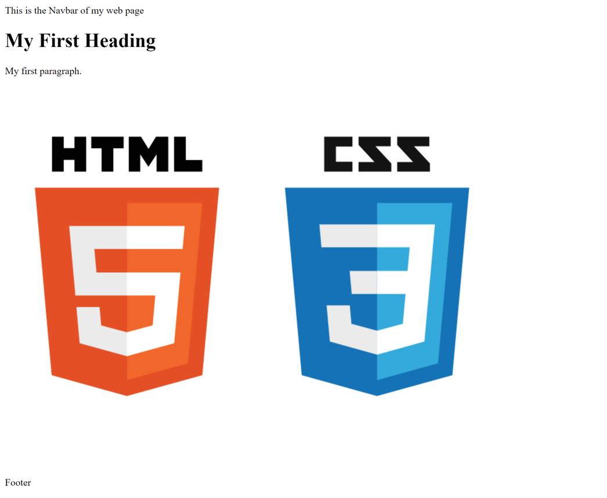
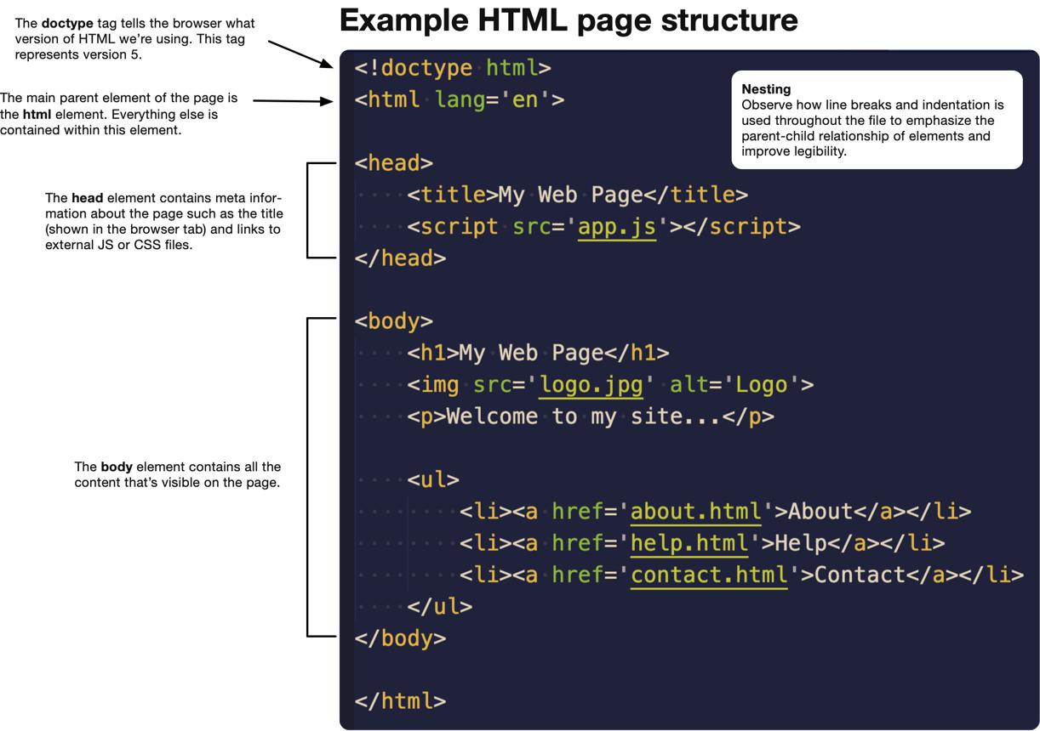
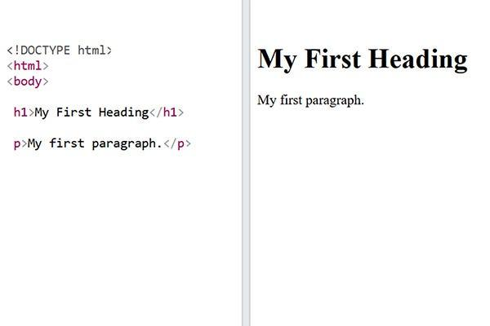
7

2. XML (Extensible Markup Language)
Used to store and transport data.
Example
<student>
<name>John</name>
<marks>90</marks>
</student>
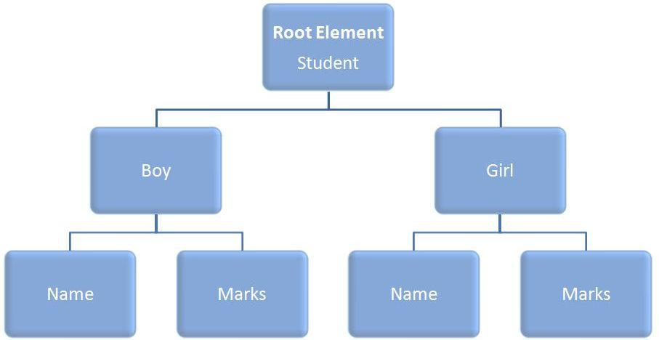
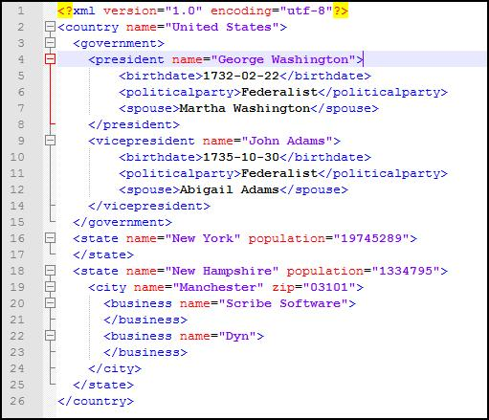
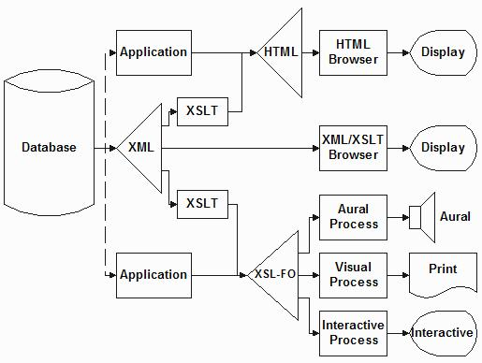
6

3. Markdown
Used for simple document formatting.
Example
# Heading
**Bold Text**
- List item

Working of Text Markup Language
Step 1: Write Text with Tags
Content is written using markup tags.

Step 2: Parsing
The system reads and understands the tags.

Step 3: Interpretation
Tags define structure and meaning.

Step 4: Rendering
Final formatted output is displayed.

Example Workflow
Raw Text → Markup Tags → Parser → Output Display

Advantages
- Organizes data clearly
- Easy to read and write
- Supports web development
- Enables data sharing
- Used in visualization systems

Disadvantages
- Needs correct syntax
- Errors break structure
- Can be complex for large documents

Real-Time Applications
Field | Application
Web Development | Website creation
Healthcare | Patient record systems
Business | Report generation
Education | Digital documents
Data Visualization | Structured data display

Real-Time Example – COVID-19 Dashboard
During the COVID-19 pandemic, text markup languages were used to:
- Structure patient data
- Build dashboards
- Display real-time statistics

Working Example
Step 1: XML Data
<covid>
<cases>10000</cases>
<recovered>9000</recovered>
</covid>

Step 2: Parsing
System reads tags and extracts values.

Step 3: Visualization
Data is displayed as:
- Charts
- Tables
- Dashboards
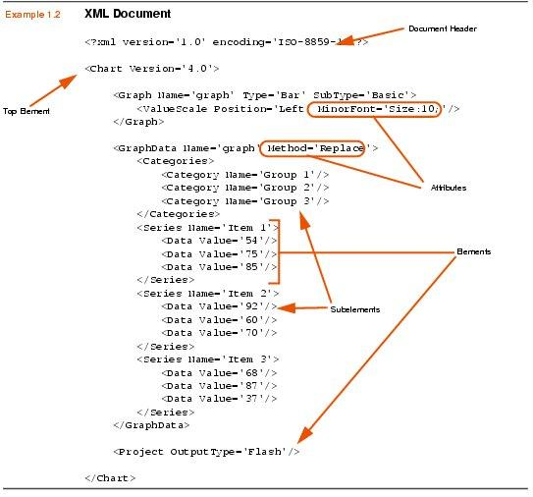
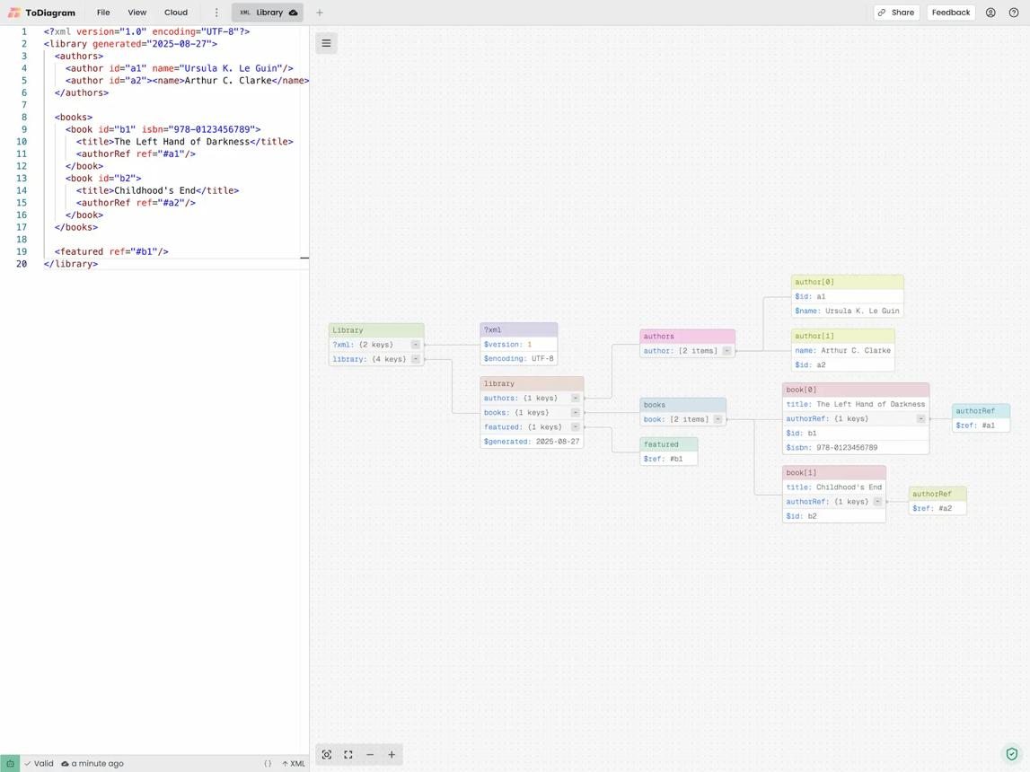
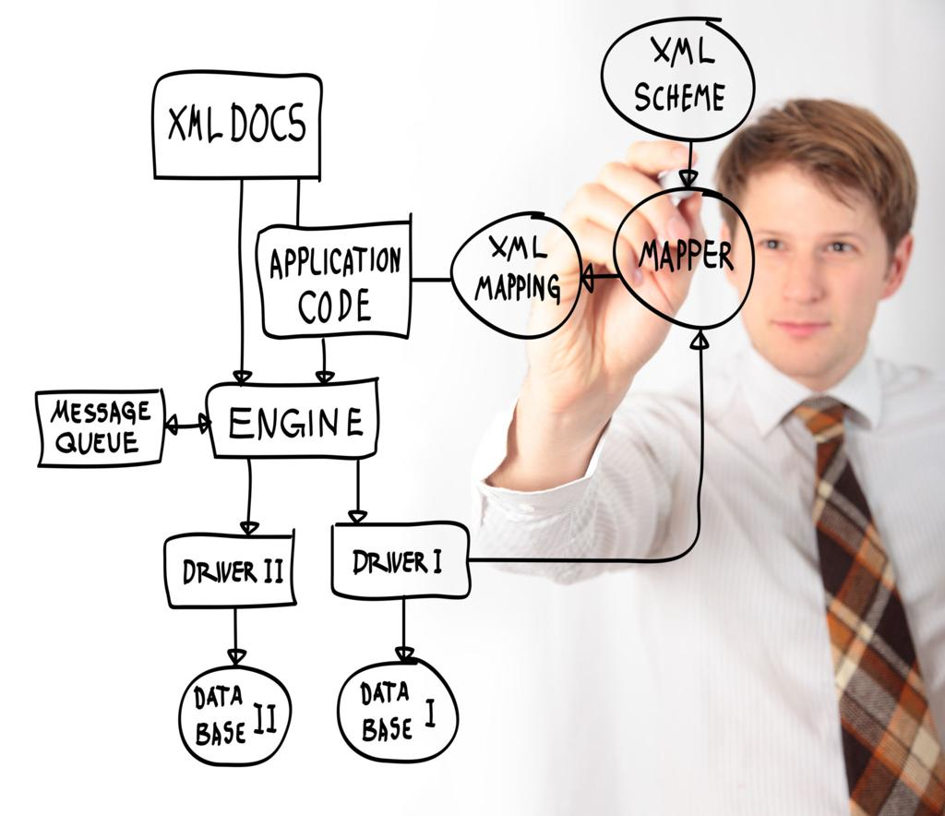
6

Conclusion
Text Markup Language is used to structure and organize text using tags. It plays an important role in web development, data visualization, and document processing by making data readable for both humans and machines.

explain for 6pages

Below is a 6-page exam-style answer on Text Markup Language, written in a structured and detailed way.

TEXT MARKUP LANGUAGE (6 PAGES)

PAGE 1: INTRODUCTION
Introduction
Text Markup Language is a method used to structure, organize, and present text data using special symbols called tags. It is widely used in computer systems to make text understandable for both humans and machines.
In simple terms, instead of writing plain text, markup language adds extra information (called markup) to describe how the text should be processed or displayed.
It plays a major role in:
- Web development
- Document formatting
- Data visualization systems
- Data exchange between applications
For example, a heading in a webpage is not just text, it is marked using tags like <h1> so that browsers know it is a heading.

Need for Text Markup Language
- To structure documents clearly
- To make data machine-readable
- To separate content from design
- To support dynamic web pages
- To enable data sharing between systems

PAGE 2: DEFINITION AND FEATURES
Definition
A Text Markup Language is a system that uses tags and symbols to define structure, meaning, and formatting of text data so that it can be interpreted by software systems.

Features of Text Markup Language
1. Tag-Based Structure
Uses tags like:
<h1>, <p>, <student>

2. Human and Machine Readable
- Humans can read easily
- Computers can process it

3. Hierarchical Structure
Data is organized in a tree-like format.

4. Platform Independent
Works in any operating system.

5. Flexible and Extensible
Users can define their own tags in XML.

Example
<h1>Data Visualization</h1>
<p>This is a paragraph</p>

PAGE 3: TYPES OF TEXT MARKUP LANGUAGES
1. HTML (HyperText Markup Language)
Used for creating web pages.
Example:
<h1>Welcome</h1>
<p>Hello World</p>
Uses:
- Websites
- Web applications
- Dashboards

2. XML (Extensible Markup Language)
Used to store and transport data.
Example:
<student>
<name>John</name>
<marks>85</marks>
</student>
Uses:
- Data storage
- APIs
- Data exchange

3. Markdown
Used for simple document formatting.
Example:
# Heading
**Bold Text**
- List item
Uses:
- Documentation
- Notes
- GitHub files

PAGE 4: WORKING OF TEXT MARKUP LANGUAGE
Working Process
Step 1: Writing Content
User writes content using tags.

Step 2: Parsing
The system reads tags and understands structure.

Step 3: Interpretation
Tags define meaning of content.

Step 4: Rendering
Final output is displayed on screen.

Workflow Diagram
Input Text → Markup Tags → Parser → Output Display

Example Working (HTML)
<h1>Hello</h1>
<p>Welcome to data visualization</p>
Output:
- Big heading appears
- Paragraph text is displayed

PAGE 5: APPLICATIONS AND REAL-TIME USES
Applications
1. Web Development
Used in creating websites and dashboards.

2. Data Visualization
Helps structure data for charts and graphs.

3. Healthcare Systems
Used for storing patient records.

4. Business Systems
Used in reports and analytics dashboards.

5. Education
Used in digital learning platforms.

Real-Time Example – COVID-19 Dashboard
During the COVID-19 pandemic, markup languages were used to:
- Display infection statistics
- Structure hospital data
- Build real-time dashboards
Example XML:
<covid>
<cases>10000</cases>
<recovered>9000</recovered>
</covid>

Output Usage
- Charts
- Maps
- Tables
- Dashboards
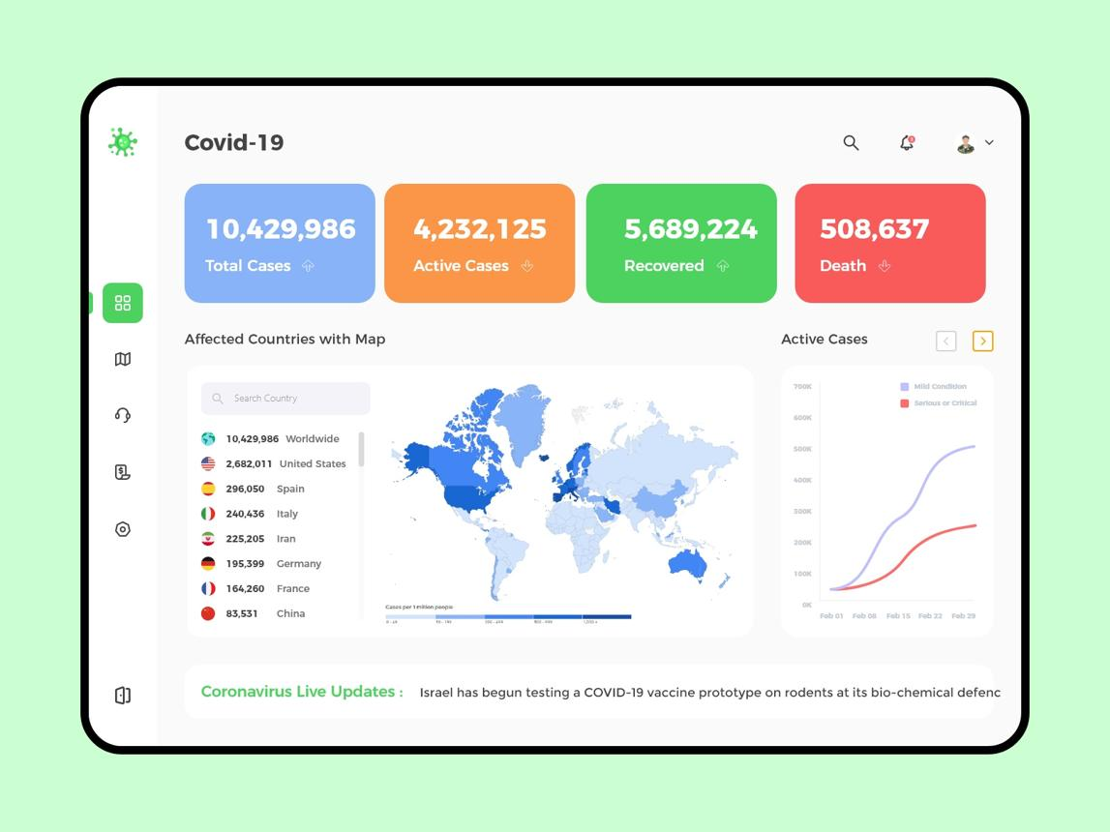
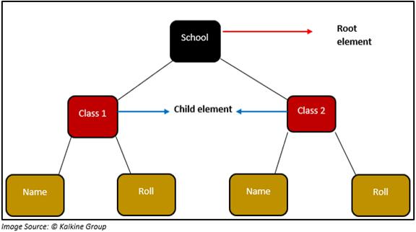
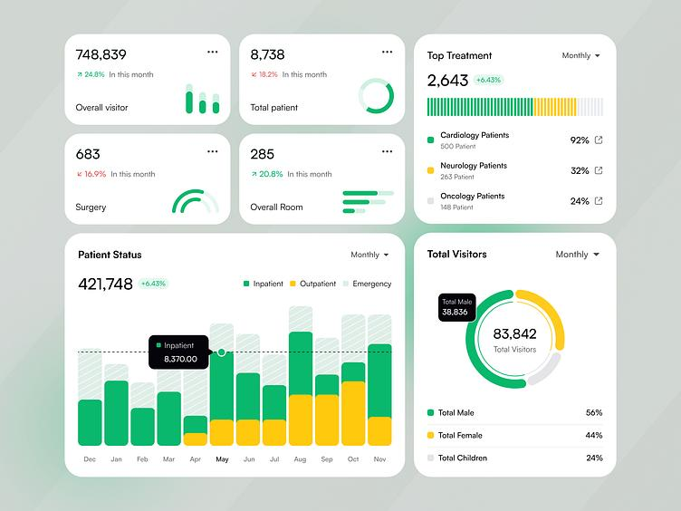
6

PAGE 6: ADVANTAGES, DISADVANTAGES & CONCLUSION
Advantages
- Easy to structure data
- Supports web development
- Machine readable
- Platform independent
- Helps in data visualization

Disadvantages
- Requires correct syntax
- Errors break structure
- Complex for large systems
- Needs learning for beginners

Comparison of Markup Languages
Language | Use
HTML | Web pages
XML | Data storage
Markdown | Simple formatting

Conclusion
Text Markup Language is an essential technology used to structure and organize text data using tags. It helps in building websites, storing data, and supporting visualization systems. It is widely used in real-world applications like healthcare dashboards, business analytics, and educational platforms.

If you want, I can also convert this into handwritten notes format, PPT, or PDF for exam submission.

Binary Data Formats

Below is a 6-page exam-ready answer on Binary Data Formats, written in clear structured form.

BINARY DATA FORMATS (6 PAGES)

PAGE 1: INTRODUCTION
Introduction
Binary Data Formats are widely used in modern computing systems to store and process data efficiently. Unlike text formats, binary formats store data in 0s and 1s, which is the natural language of computers.
In data visualization and processing systems, binary formats help handle:
- Large datasets
- Images and videos
- Scientific data
- Real-time applications
They are important because they provide faster processing, reduced storage size, and efficient data transfer.

Need for Binary Data Formats
- Reduce file size
- Improve processing speed
- Store complex data efficiently
- Support multimedia applications
- Enable real-time visualization systems

PAGE 2: DEFINITION AND FEATURES
Definition
Binary Data Formats are file formats that store data in binary form (0s and 1s) instead of human-readable text.

Features
1. Machine Readable
Only computers can directly understand binary data.

2. Compact Storage
Uses less memory compared to text formats.

3. High Speed Processing
Faster reading and writing operations.

4. Efficient Transmission
Data can be transferred quickly over networks.

5. Supports Complex Data
Used for images, audio, video, and databases.

Example Representation
Character: A
Binary: 01000001

PAGE 3: TYPES OF BINARY DATA FORMATS
1. Image Formats
Used to store image data.
Examples:
- JPEG (.jpg)
- PNG (.png)
- BMP
Use:
- Medical imaging
- Photo storage

2. Audio Formats
Used for sound storage.
Examples:
- MP3
- WAV
- AAC

3. Video Formats
Used for multimedia storage.
Examples:
- MP4
- AVI
- MKV

4. Structured Data Formats
Used for storing structured information.
Examples:
- BSON
- Protocol Buffers
- SQLite files

5. Compressed Formats
Used to reduce file size.
Examples:
- ZIP
- RAR

PAGE 4: WORKING OF BINARY DATA FORMATS
Working Process
Step 1: Data Input
Data is collected from sources like text, images, or sensors.

Step 2: Conversion
Data is converted into binary (0s and 1s).

Step 3: Encoding
Data is encoded using specific formats.

Step 4: Compression
Unnecessary data is reduced.

Step 5: Storage
Binary data is stored in files or databases.

Step 6: Decoding
Data is converted back for display or visualization.

Workflow Diagram
Input Data → Encoding → Binary Conversion → Storage → Decoding → Output

Example
Original:
Hello
Binary:
01001000 01100101 01101100 01101100 01101111

PAGE 5: APPLICATIONS AND REAL-TIME USES
Applications
1. Healthcare
Used in storing medical images and reports.

2. Multimedia Systems
Used in video and audio streaming.

3. Databases
Efficient storage of large structured data.

4. Web Systems
Faster data exchange using binary APIs.

5. Data Visualization
Helps process large datasets quickly.

Real-Time Example – COVID-19 Systems
During the COVID-19 pandemic, binary formats were widely used for:
- CT scan images
- Hospital records
- Vaccination data
- Large dataset transmission

Working Example
Step 1: Data Collection
Hospitals collect patient data.

Step 2: Conversion
Images and reports are converted into binary format.

Step 3: Transmission
Data is sent to servers.

Step 4: Visualization
Data is decoded and displayed in dashboards.

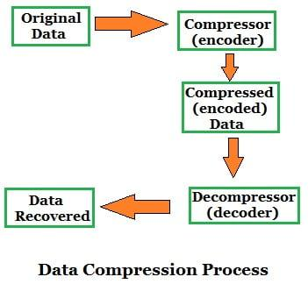
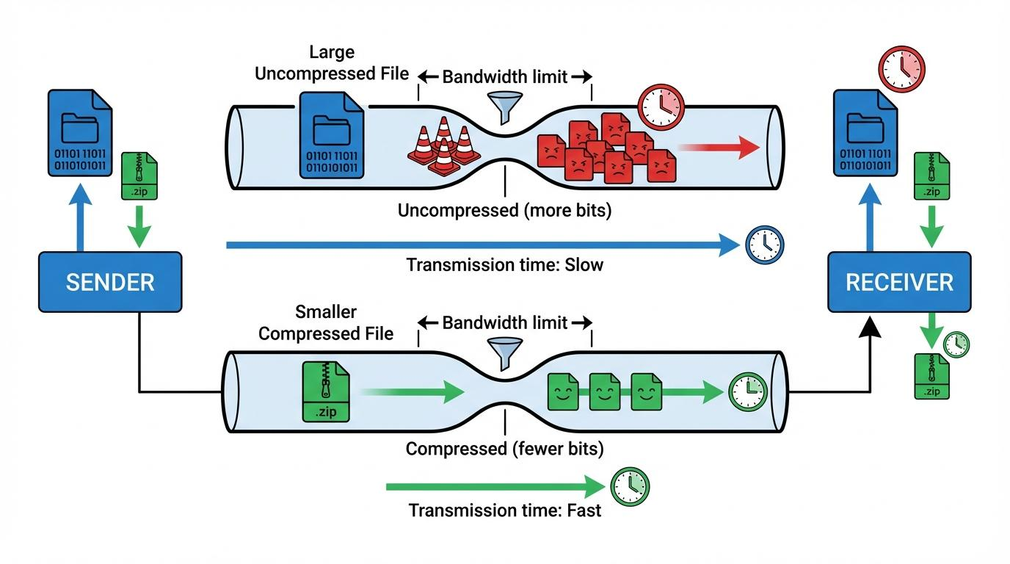
6

PAGE 6: ADVANTAGES, DISADVANTAGES & CONCLUSION
Advantages
- Fast processing speed
- Reduced storage size
- Efficient data transfer
- Suitable for large datasets
- Used in real-time systems

Disadvantages
- Not human-readable
- Requires decoding tools
- Complex structure
- Hard to debug manually

Comparison
Feature | Binary Format | Text Format
Readability | Low | High
Speed | High | Low
Storage | Small | Large

Conclusion
Binary Data Formats are essential in modern computing systems for efficient storage, fast processing, and real-time data handling. They are widely used in healthcare, multimedia, databases, and data visualization systems where performance is critical.

If you want, I can also convert this into a PDF notes format or exam revision sheet (short answers + diagrams).

, Advanced Detective Work.

Advanced Detective Work (Data & Document Visualization)

PAGE 1: INTRODUCTION
Introduction
Advanced detective work refers to the use of advanced data analysis, visualization, and computational techniques to investigate data and discover hidden patterns, anomalies, and meaningful insights.
In data and document visualization, it acts like a digital investigation process, where data is treated as clues and analyzed systematically.
It is widely used in:
- Cybersecurity
- Fraud detection
- Healthcare analytics
- Criminal investigation systems
- Business intelligence
- Social media analysis

Need for Advanced Detective Work
- To find hidden patterns in large datasets
- To detect fraud or suspicious activity
- To support decision-making
- To improve system security
- To analyze complex relationships

PAGE 2: DEFINITION AND FEATURES
Definition
Advanced detective work is the process of using data analysis, visualization techniques, and intelligent algorithms to detect hidden patterns, anomalies, and relationships in complex datasets.

Features
1. Pattern Discovery
Finds repeated or meaningful trends in data.

2. Anomaly Detection
Identifies unusual or suspicious data points.

3. Data-Driven Investigation
Uses real data instead of assumptions.

4. Visualization-Based Analysis
Uses graphs, charts, and networks.

5. Real-Time Monitoring
Works on live data streams.

Example
- Detecting unusual bank transactions
- Finding abnormal network activity

PAGE 3: KEY TECHNIQUES
1. Data Mining
Extracts hidden information from large datasets.

2. Pattern Recognition
Identifies repeating structures in data.

3. Anomaly Detection
Finds outliers or unusual behavior.

4. Text Mining
Analyzes documents, emails, and logs.

5. Network Analysis
Studies relationships between entities.

Visualization Tools Used
- Heatmaps
- Graph networks
- Dashboards
- Scatter plots
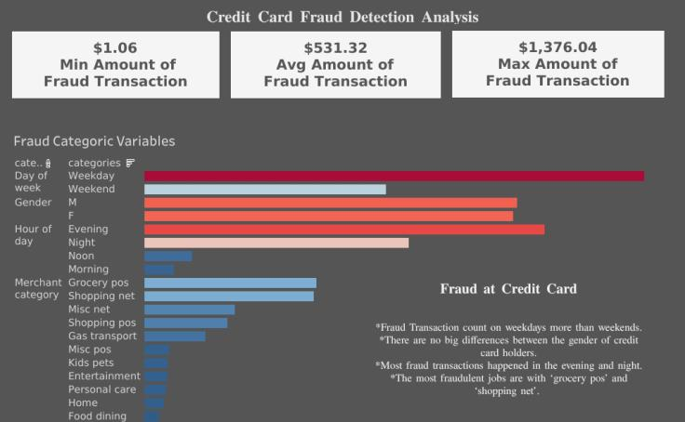
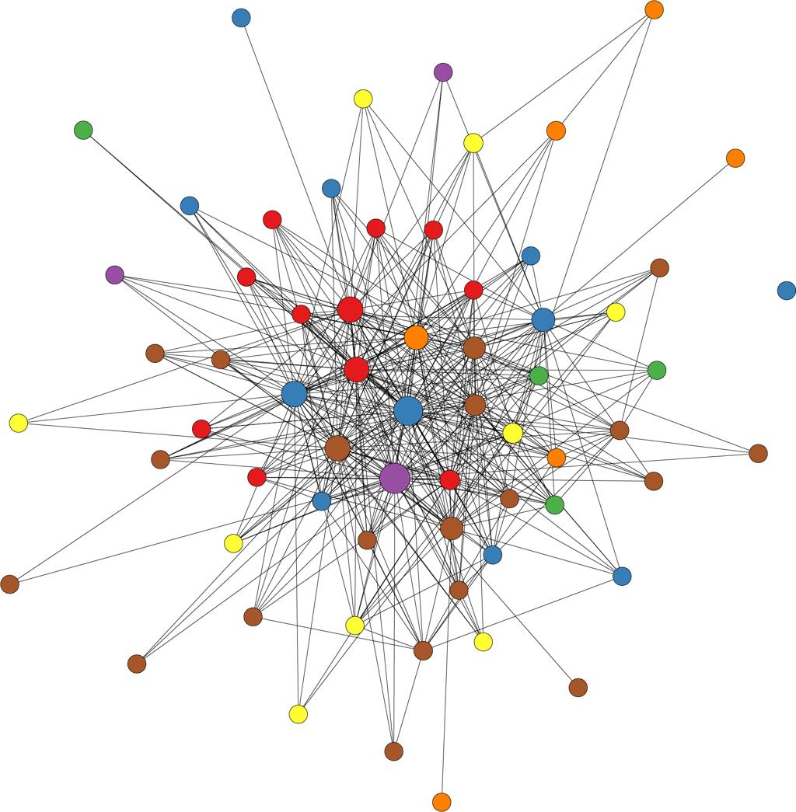
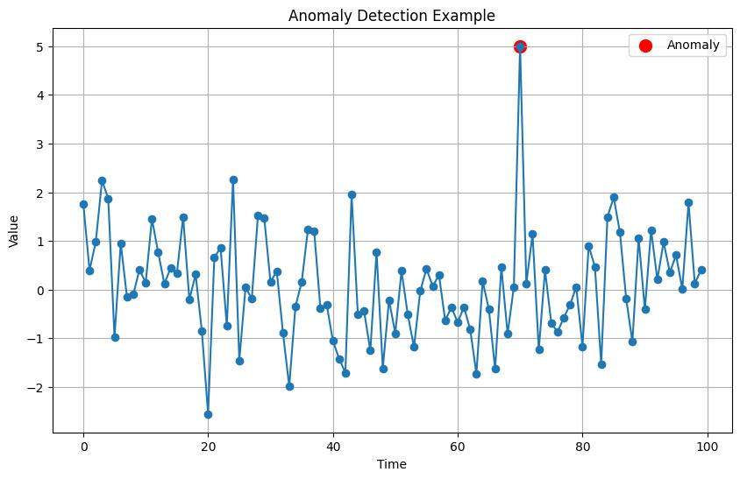
8

PAGE 4: WORKING OF ADVANCED DETECTIVE WORK
Working Process
Step 1: Data Collection
Data is collected from multiple sources:
- Databases
- Logs
- Sensors
- Documents
- Social media

Step 2: Data Cleaning
Irrelevant or duplicate data is removed.

Step 3: Data Analysis
Algorithms analyze:
- Patterns
- Trends
- Outliers
- Relationships

Step 4: Visualization
Results are displayed using:
- Graphs
- Heatmaps
- Network diagrams

Step 5: Interpretation
Humans interpret insights and make decisions.

Workflow Diagram
Data Collection → Cleaning → Analysis → Visualization → Interpretation

PAGE 5: REAL-TIME APPLICATIONS
Applications
1. Banking
Fraud detection in transactions.

2. Cybersecurity
Detecting hacking attempts.

3. Healthcare
Analyzing disease spread patterns.

4. Business Intelligence
Customer behavior analysis.

5. Law Enforcement
Criminal network tracking.

Real-Time Example – COVID-19 Analysis
During the COVID-19 pandemic, advanced detective work was used to:
- Track infection clusters
- Identify hotspots
- Analyze spread patterns

Working Example
Step 1: Data Collection
Hospitals collected patient data.
Step 2: Analysis
Authorities analyzed:
- Infection rates
- Location data
- Recovery trends
Step 3: Visualization
Data was shown using:
- Heatmaps
- Line graphs
- Geographic maps
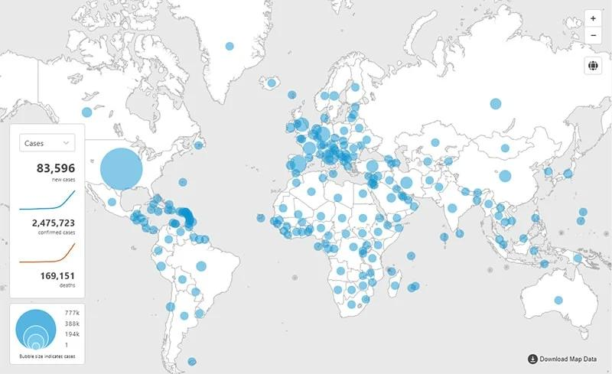
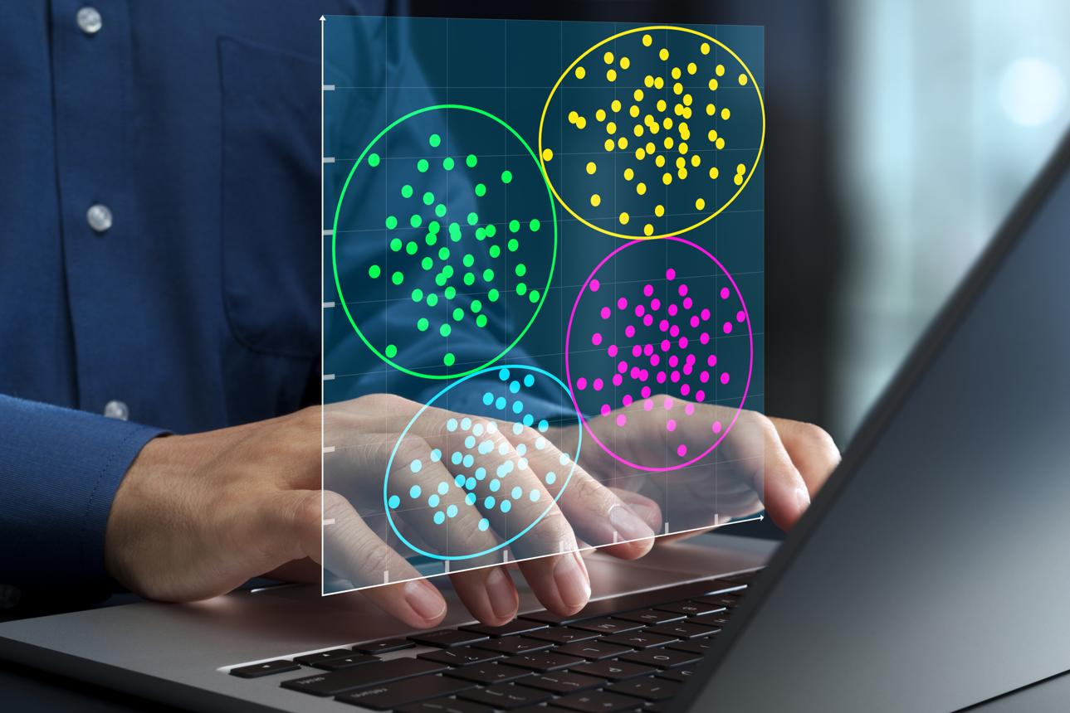
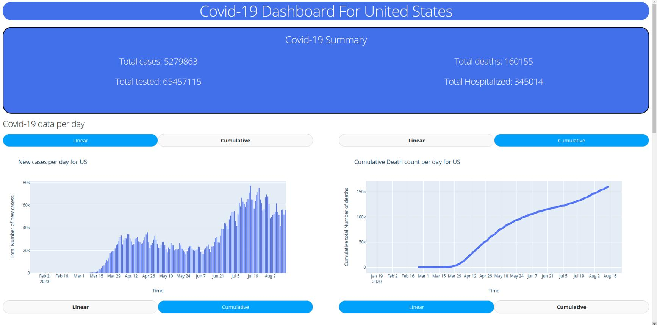
7

PAGE 6: ADVANTAGES, DISADVANTAGES & CONCLUSION
Advantages
- Detects hidden patterns
- Improves security systems
- Works with large datasets
- Supports real-time analysis
- Helps decision-making

Disadvantages
- Requires advanced tools
- High computational cost
- Complex algorithms
- Privacy concerns

Conclusion
Advanced detective work is a powerful data analysis approach used to uncover hidden patterns, detect anomalies, and support decision-making. It is essential in cybersecurity, healthcare, business intelligence, and real-world investigation systems where data plays a crucial role.

If you want, I can also convert all your Unit-III topics into a single revision PDF / handwritten notes / exam cheat sheet.

, Regular Expressions, Grammars and BNF Notation

Below is a 6-page exam-ready answer covering Regular Expressions, Grammars, and BNF Notation in a structured way.

REGULAR EXPRESSIONS, GRAMMARS AND BNF NOTATION (6 PAGES)

PAGE 1: INTRODUCTION
Introduction
In text and document processing, we often need to:
- Search patterns in text
- Validate data formats
- Structure programming languages
- Parse documents and datasets
For this, we use:
- Regular Expressions (Regex) → pattern matching in text
- Grammars → rules for forming valid structures
- BNF (Backus–Naur Form) → formal notation of grammar
These concepts are very important in:
- Data visualization systems
- Compilers
- Web development
- Text processing
- Artificial intelligence

Importance
- Helps in data cleaning
- Ensures correct data format
- Supports parsing and visualization
- Used in programming languages design

PAGE 2: REGULAR EXPRESSIONS
Definition
A Regular Expression is a pattern used to search, match, extract, or replace text in strings.

Features
- Pattern-based search
- Fast text processing
- Works with large datasets
- Used in validation

Basic Symbols
Symbol | Meaning
. | Any character
* | Zero or more
+ | One or more
? | Optional
^ | Start
$ | End
[0-9] | Digits

Example
Find numbers in text:
Age: 25, Marks: 90
Regex:
\d+
Output:
- 25
- 90

Working of Regex
- Input text
- Define pattern
- Match data
- Extract or replace

Real-Time Use
- Email validation
- Log file analysis
- Data cleaning

PAGE 3: GRAMMARS
Definition
A Grammar is a set of rules that defines how valid sentences or expressions are formed in a language.

Components of Grammar
1. Terminals
Actual symbols
Example: a, b, +

2. Non-Terminals
Variables representing structure
Example: <expr>

3. Production Rules
Rules for rewriting symbols
Example:
E → E + T

4. Start Symbol
Beginning of grammar
Example: E

Example Grammar
E → E + T | T
T → T * F | F
F → (E) | id

Working of Grammar
- Start symbol is chosen
- Apply rules
- Generate valid expression
- Validate structure

Example
Expression:
3 + 5 * 2
Grammar defines correct structure and operator order.

PAGE 4: BNF NOTATION
Definition
BNF (Backus–Naur Form) is a formal way to represent grammar rules used in programming languages and data structures.

Syntax
<symbol> ::= expression
- ::= means “is defined as”
- < > indicates non-terminal

Example BNF (Arithmetic Expression)
<expr> ::= <expr> + <term> | <term>
<term> ::= <term> * <factor> | <factor>
<factor> ::= ( <expr> ) | number

Working of BNF
- Define grammar rules
- Parse input string
- Check validity
- Build structure (parse tree)

Parse Tree Example
Expression:
3 + 5 * 2
Structure:
+
/ \
3 *
/ \
5 2

PAGE 5: RELATIONSHIP AND APPLICATIONS
Relationship Between Them
Concept | Function
Regex | Pattern matching in text
Grammar | Rules for structure
BNF | Formal representation of grammar

Applications
1. Compilers
- Grammar defines programming language structure
- BNF describes syntax rules

2. Web Development
- HTML/XML parsing
- Data validation

3. Data Visualization
- Parsing structured data
- Cleaning datasets

4. Text Processing
- Search and filter data
- Extract information

5. NLP Systems
- Sentence structure analysis
- Language modeling

Real-Time Example – COVID-19 Data Processing
During the COVID-19 pandemic:
- Regex used to extract case numbers
- Grammar used to structure reports
- BNF used to define JSON/XML formats

Example JSON Grammar
<report> ::= { <cases>, <deaths>, <recovered> }
<cases> ::= number

PAGE 6: ADVANTAGES, DISADVANTAGES & CONCLUSION
Advantages
Regular Expressions
- Fast text search
- Efficient data filtering
Grammar
- Defines language structure
- Helps in parsing
BNF
- Formal and precise
- Used in compilers

Disadvantages
- Regex is complex for beginners
- Grammar design is difficult
- BNF is strict and less flexible

Comparison Table
Concept | Use
Regex | Text pattern matching
Grammar | Language structure rules
BNF | Formal syntax definition

Conclusion
Regular Expressions, Grammars, and BNF Notation are essential tools in computing for processing and structuring data. They are widely used in compilers, data visualization, web systems, and text processing applications to ensure data is correctly formatted, validated, and analyzed efficiently.

If you want, I can also convert this into a short revision sheet or handwritten exam notes format for quick study.

Vectors and Geometry

Below is a 6-page exam-ready answer on Vectors and Geometry in a clear structured format.

VECTORS AND GEOMETRY (6 PAGES)

PAGE 1: INTRODUCTION
Introduction
Vectors and Geometry are fundamental concepts used in mathematics, computer graphics, and data visualization. They help in representing:
- Position of objects
- Direction and movement
- Shapes and spatial relationships
- Graphs and visual data
In data visualization systems, vectors and geometry are used to:
- Draw graphs and charts
- Represent networks
- Create animations
- Build maps and dashboards

Importance
- Helps in spatial understanding of data
- Used in computer graphics and visualization
- Represents real-world movement and direction
- Supports scientific and engineering applications

PAGE 2: VECTORS
Definition
A vector is a quantity that has both:
- Magnitude (size)
- Direction

Representation
A vector is written as:
(x, y) or (x, y, z)

Example
- Movement of a car
- Wind direction
- GPS navigation path

Types of Vectors
1. Position Vector
Represents location of a point
Example: (2, 3)

2. Direction Vector
Shows direction of movement
Example: North-East direction

3. Zero Vector
No magnitude or direction
(0, 0)

Vector Operations
Addition
(2,3) + (1,2) = (3,5)
Subtraction
(5,4) - (2,1) = (3,3)
Scalar Multiplication
2 × (3,4) = (6,8)

PAGE 3: GEOMETRY
Definition
Geometry is the study of shapes, sizes, positions, and properties of objects in space.

Basic Elements of Geometry
1. Point
A single location
Example: (x, y)

2. Line
A straight path between points

3. Plane
A flat surface

4. Shapes
- Triangle
- Circle
- Rectangle
- Polygon

Geometry in Visualization
- Shapes represent data
- Graphs use points and lines
- Maps use geometric coordinates

PAGE 4: RELATIONSHIP BETWEEN VECTORS AND GEOMETRY
Vectors are used to represent geometric objects mathematically.

Mapping
Geometry | Vector Representation
Point | (x, y)
Line | Direction vector
Shape | Multiple vectors
Movement | Vector path

Example
Points:
A(1,2), B(4,6)
Vector:
AB = (4-1, 6-2) = (3,4)

Diagram
A •────────• B
Vector AB = (3,4)

Working in Visualization
- Define coordinates
- Create vectors
- Connect points
- Generate shapes
- Display graph

PAGE 5: APPLICATIONS
1. Data Visualization
- Scatter plots
- Graph networks
- Heat maps

2. Computer Graphics
- Animation
- 3D modeling
- Game development

3. Navigation Systems
Used in GPS and mapping systems

4. Physics Simulation
- Motion
- Force
- Velocity

5. Networking
Used in node-link graphs

Real-Time Example – Navigation System
In systems like Google Maps:
- Locations are points (vectors)
- Routes are geometric paths
- Directions are vector movements

Working Example
Step 1: Start Point
Chennai → (x1, y1)
Step 2: End Point
Bangalore → (x2, y2)
Step 3: Vector Calculation
Direction and distance are computed
Step 4: Visualization
Route is displayed on map
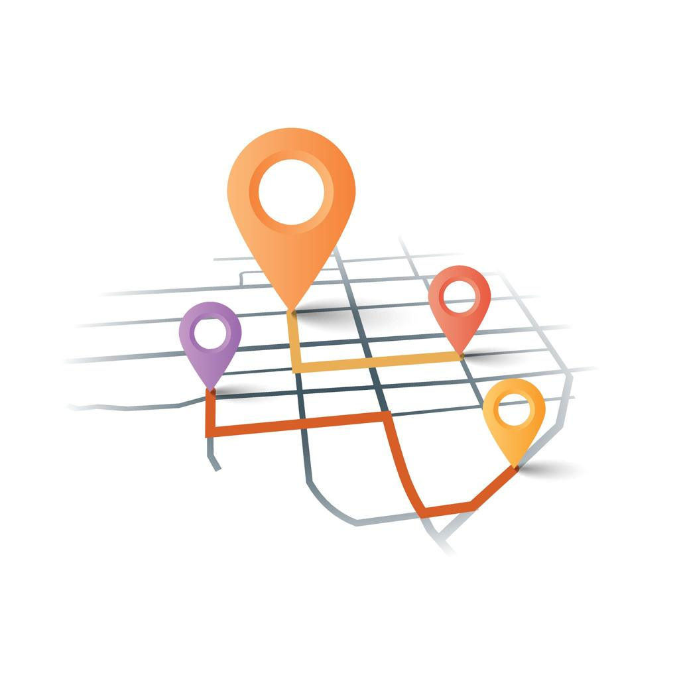
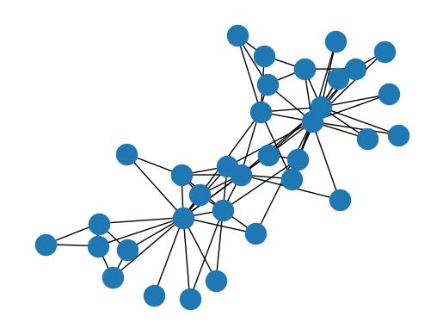
7

PAGE 6: ADVANTAGES, DISADVANTAGES & CONCLUSION
Advantages
- Helps represent spatial data
- Used in graphics and visualization
- Improves data understanding
- Supports real-world modeling
- Useful in scientific analysis

Disadvantages
- Requires mathematical knowledge
- Complex in higher dimensions
- Difficult for beginners

Comparison
Vectors | Geometry
Direction & magnitude | Shapes & structures
Movement representation | Object representation
Used in calculations | Used in visualization

Conclusion
Vectors and Geometry are essential mathematical tools used to represent positions, shapes, and movements in space. They are widely used in data visualization, computer graphics, navigation systems, and real-time applications like mapping and simulation.

If you want, I can also combine all Unit-III topics into one complete 50-page PDF revision note or handwritten-style exam guide.

explain in data visualization

Vectors and Geometry in Data Visualization
Introduction
In data visualization, vectors and geometry are used to represent data in a spatial form. Instead of showing data only as numbers, we map it into points, lines, shapes, and directions so that patterns become easy to understand.
They are mainly used in:
- Graphs and charts
- Maps and navigation systems
- Network diagrams
- Scatter plots
- 3D visualizations

Vectors in Data Visualization
Meaning
A vector represents data as:
- Position (where the data point is)
- Direction (trend or movement)
- Magnitude (strength or value)

How Vectors are Used
1. Scatter Plot Representation
Each data point is treated as a vector:
(x, y) → data point position
Example:
- Student marks → (Math score, Science score)
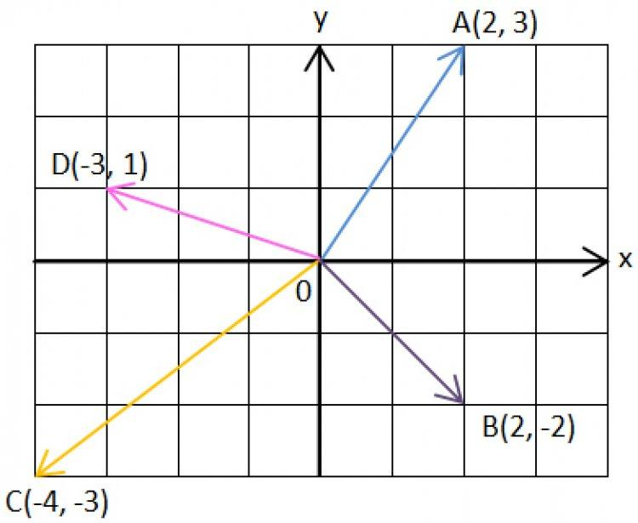
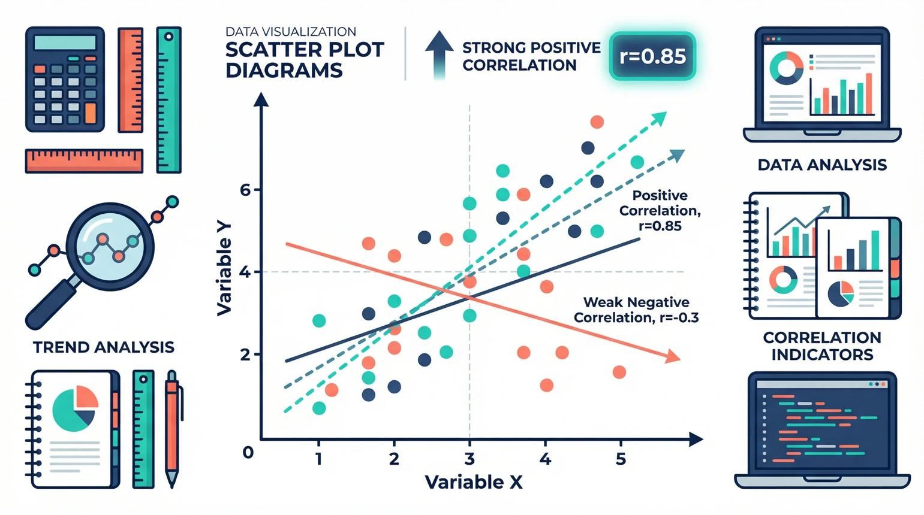
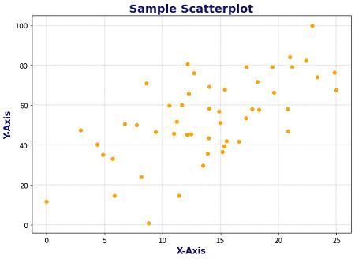
6

2. Directional Data (Trend Analysis)
Vectors show movement of data:
- Stock price increase
- Population growth
- Weather wind direction
Example:
(+) upward vector → increasing trend
(-) downward vector → decreasing trend

3. Flow Visualization
Used in:
- Traffic flow maps
- Wind flow maps
- Network data flow

Geometry in Data Visualization
Meaning
Geometry helps represent data using:
- Points
- Lines
- Shapes
- Surfaces
It converts raw data into visual structures.

How Geometry is Used
1. Points
Each data value is shown as a point.
Example:
- Sales data of different cities

2. Lines
Used to show trends over time.
Example:
- Time series graph (sales per month)
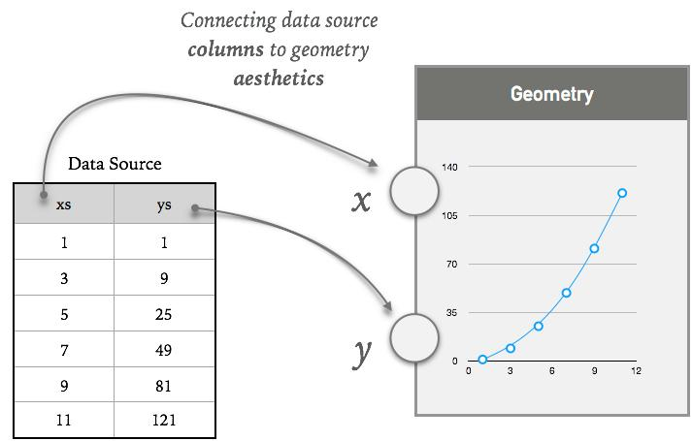
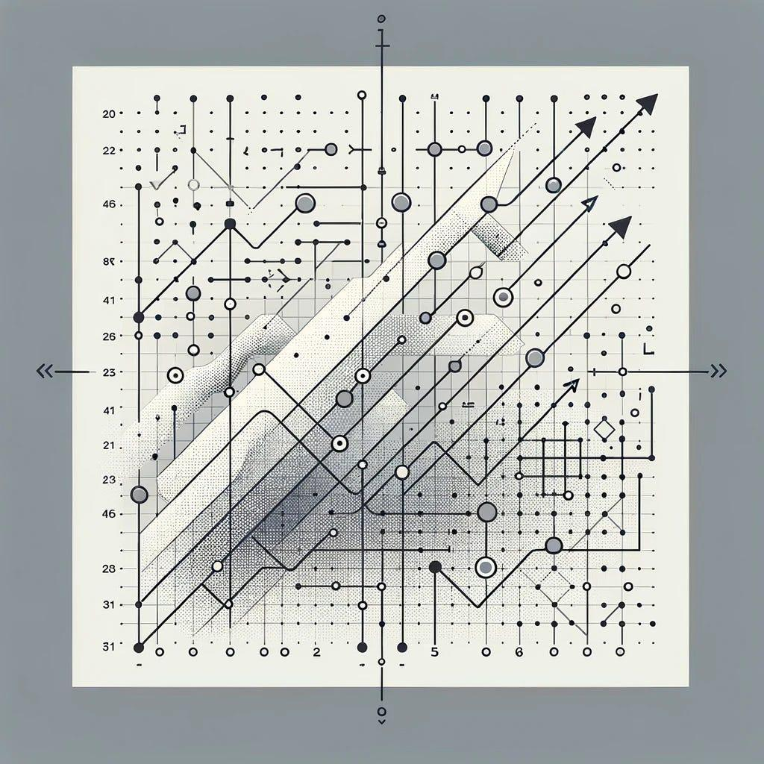
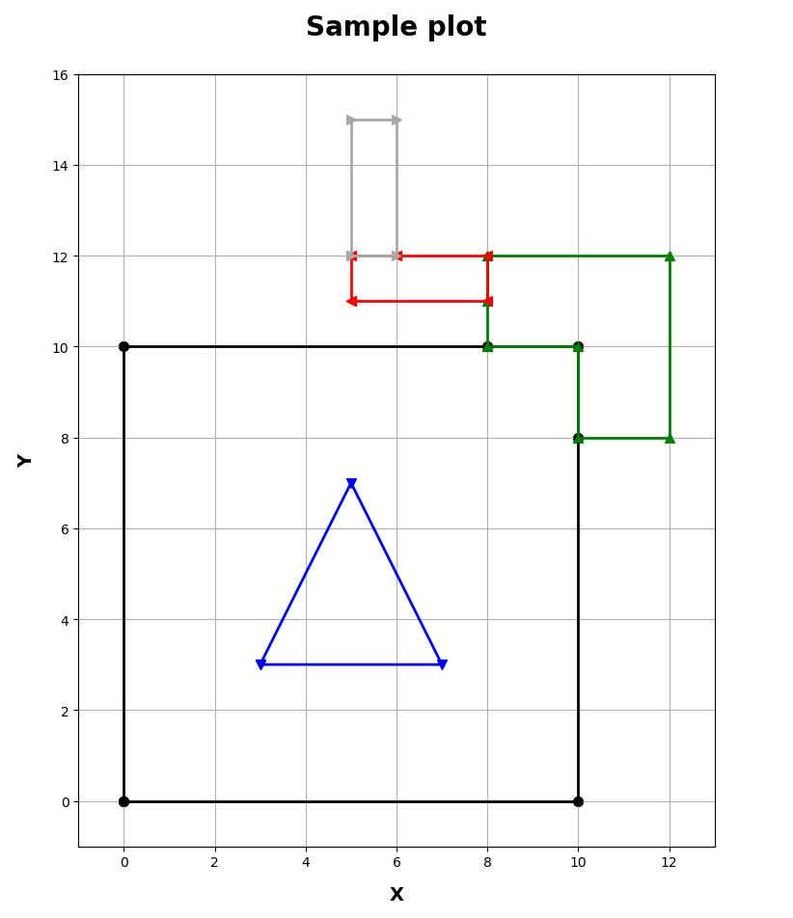
6

3. Shapes
Used in:
- Pie charts
- Treemaps
- Infographics
Example:
- Market share visualization using circles or slices

4. Networks (Graph Geometry)
Used to show relationships:
- Social media connections
- Transport networks
- Brain networks
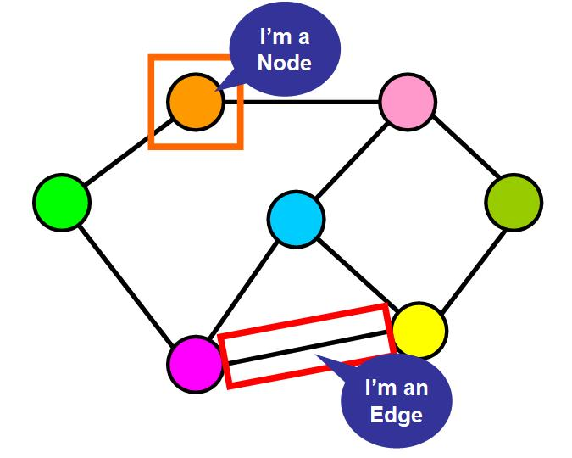
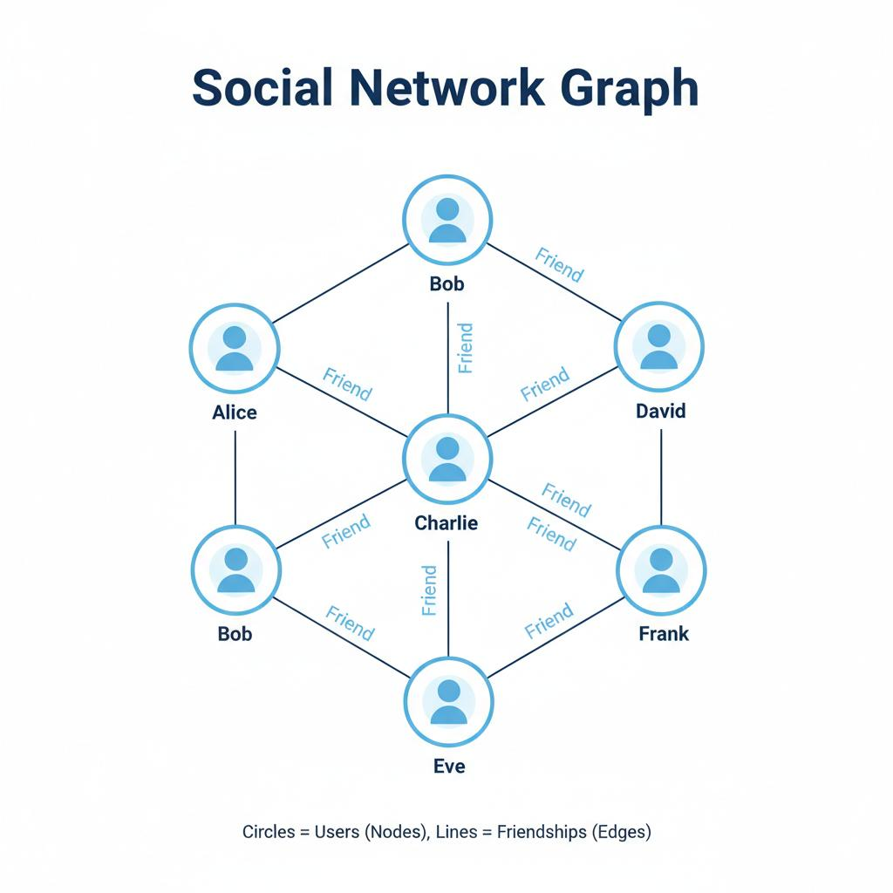
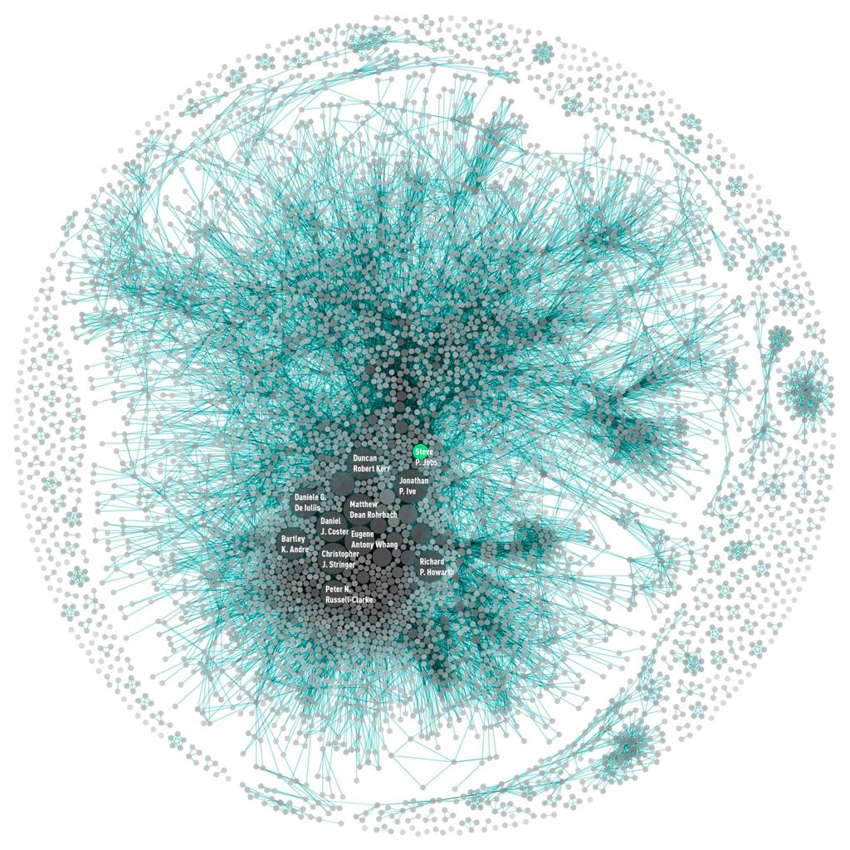
7

Working of Vectors and Geometry in Visualization
Step 1: Data Collection
Example:
- Student marks
- Sales data
- Weather data

Step 2: Convert into Coordinates
Data is mapped into:
- (x, y) or (x, y, z)

Step 3: Apply Geometry
- Points → data values
- Lines → trends
- Shapes → groups

Step 4: Visualization
Data is displayed as:
- Graphs
- Charts
- Maps
- Dashboards

Real-Time Example – Navigation System
In systems like Google Maps:
- Locations are vectors (coordinates)
- Routes are geometric lines
- Directions are vector movements
- Traffic is shown as flow visualization

Example
From Chennai → Bangalore:
- Start point = vector A
- End point = vector B
- Route = geometric line
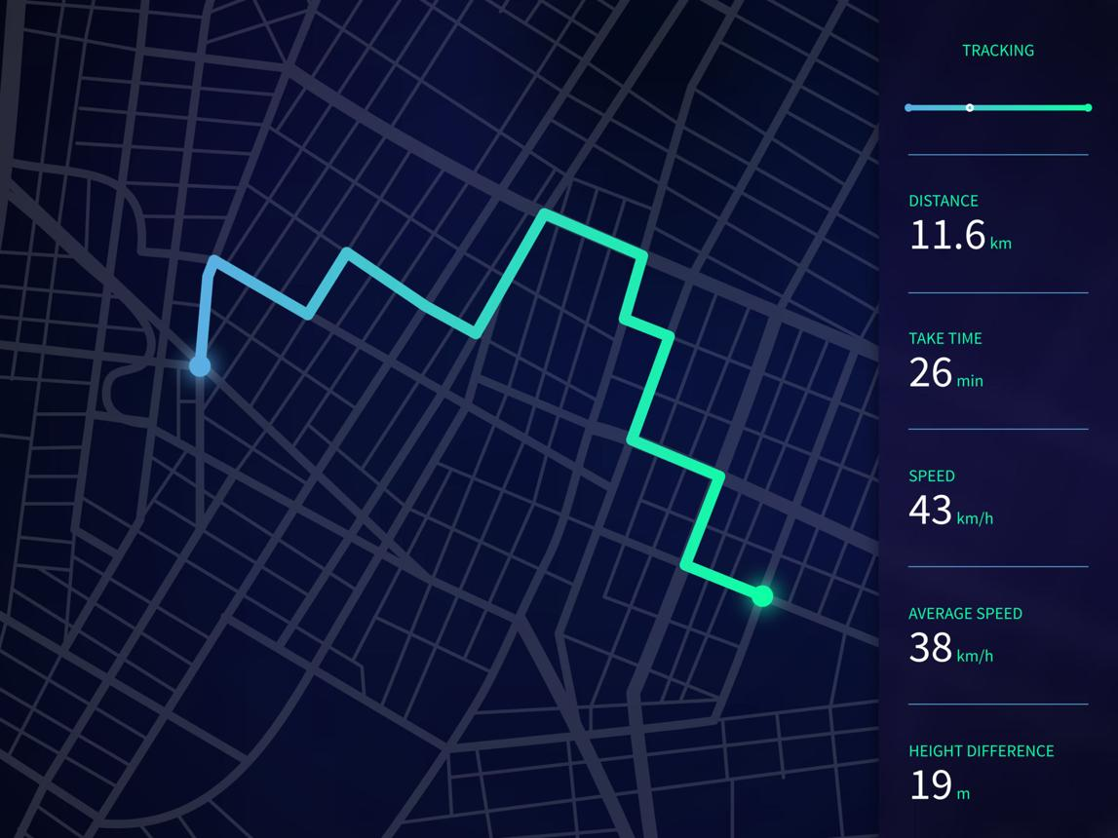
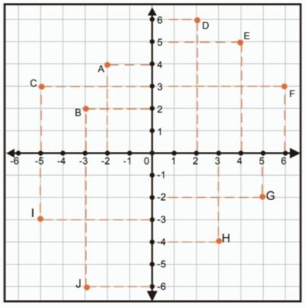
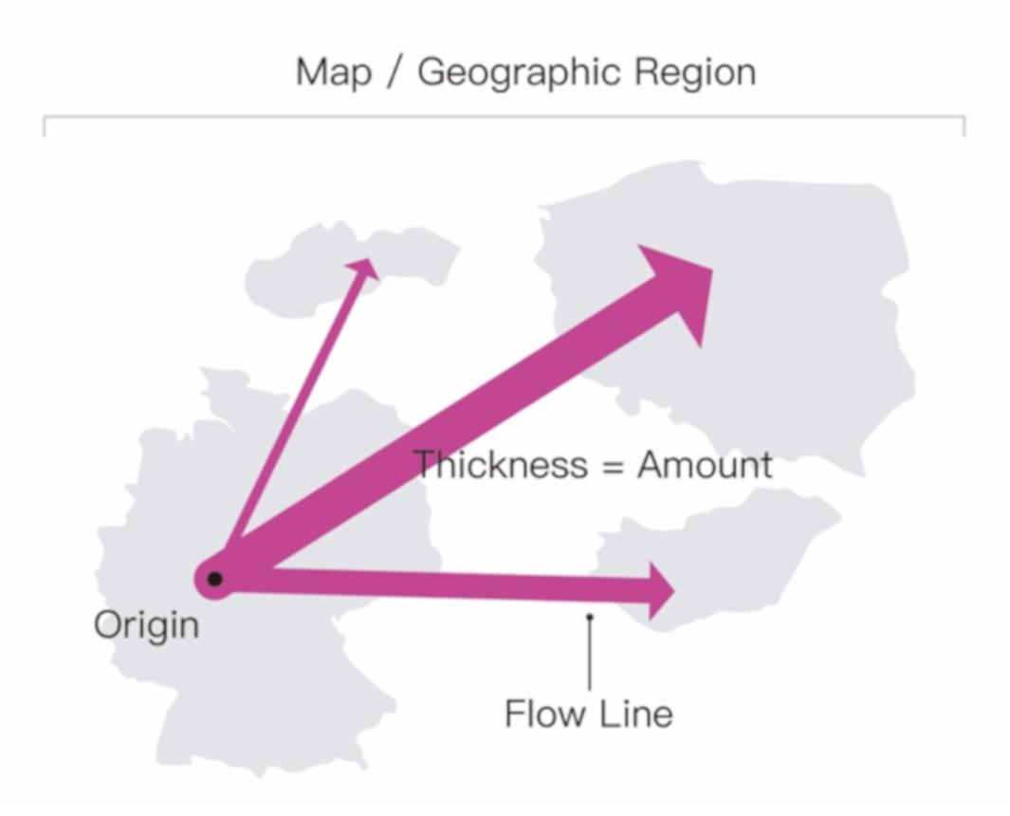
6

Advantages
- Makes data easy to understand
- Shows patterns visually
- Useful for large datasets
- Helps in trend analysis
- Used in real-time systems

Conclusion
In data visualization, vectors represent position, direction, and movement, while geometry represents shapes, structures, and relationships. Together, they help convert raw data into meaningful visual patterns such as graphs, maps, and networks.

Advanced Detective Work.

Advanced Detective Work (in Data Visualization)
Introduction
Advanced detective work in data visualization refers to the process of investigating data like a detective to discover hidden patterns, anomalies, relationships, and useful insights using visualization techniques.
Instead of reading raw data, we analyze it using:
- Graphs
- Charts
- Heatmaps
- Networks
- Dashboards
It helps convert complex data into visual clues for decision-making.

Definition
Advanced detective work is the use of data analysis, visualization, and computational techniques to detect hidden patterns, anomalies, and meaningful insights from large and complex datasets.

Purpose
- Identify hidden patterns in data
- Detect unusual or suspicious behavior
- Support decision-making
- Improve system security
- Analyze complex relationships

Key Idea (Detective Approach)
In visualization:
- Data = Evidence
- Patterns = Clues
- Graphs = Investigation tools
- Insights = Final conclusion

Techniques Used
1. Pattern Recognition
Finding repeated trends in data.
Example:
- Regular increase in sales every month

2. Anomaly Detection
Finding unusual values.
Example:
- Sudden spike in bank transactions
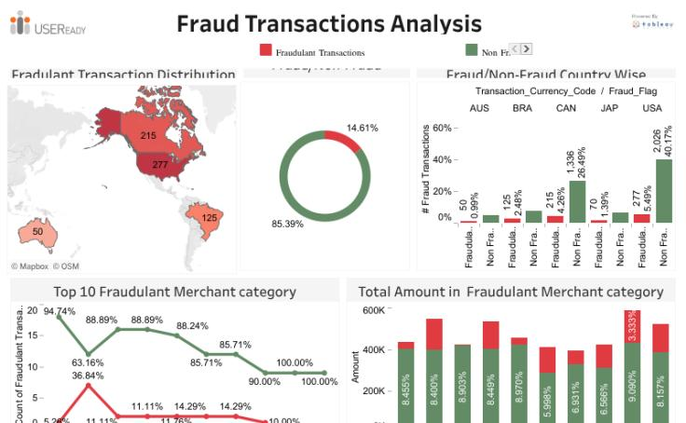
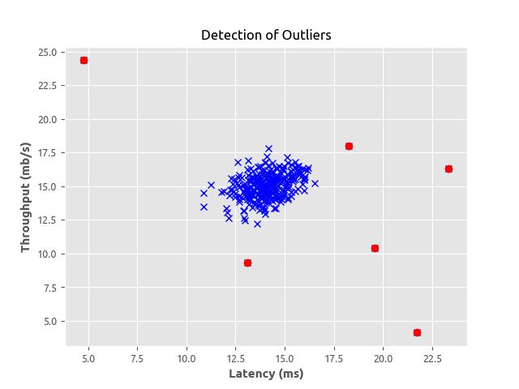
6

3. Data Mining
Extracting hidden information from large datasets.
Example:
- Customer buying behavior

4. Network Analysis
Studying relationships between data points.
Example:
- Social media connections

5. Text Analysis
Analyzing documents and logs for clues.

Working of Advanced Detective Work
Step 1: Data Collection
Data is collected from:
- Databases
- Sensors
- Logs
- Websites

Step 2: Data Cleaning
Remove:
- Errors
- Duplicate data
- Missing values

Step 3: Data Analysis
Find:
- Trends
- Patterns
- Outliers

Step 4: Visualization
Convert data into:
- Graphs
- Heatmaps
- Networks

Step 5: Interpretation
Humans analyze and make decisions.

Real-Time Example – Banking Fraud Detection
A bank monitors transactions:
Transaction | Amount | Location
T1 | 2000 | Chennai
T2 | 2500 | Chennai
T3 | 50000 | Foreign country
Detection:
- T3 is unusual → flagged as suspicious

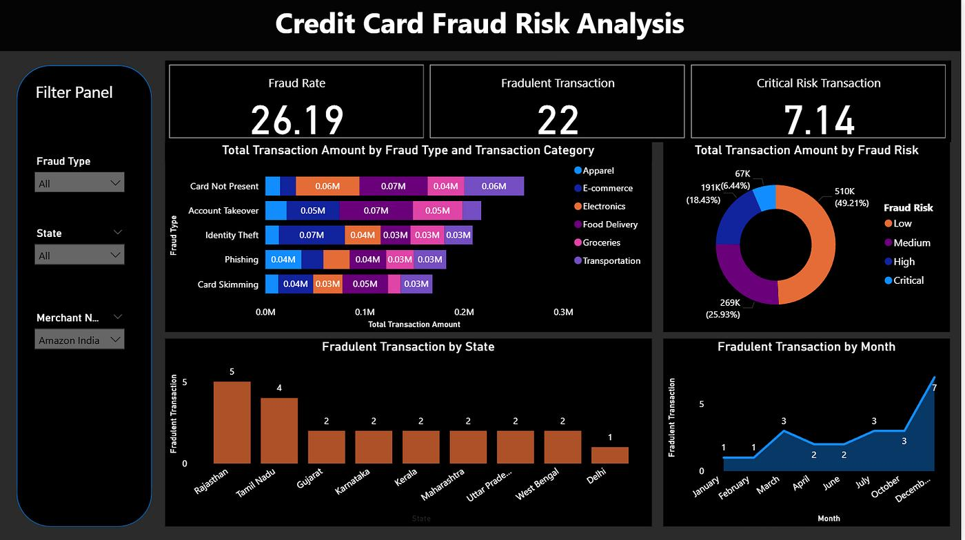
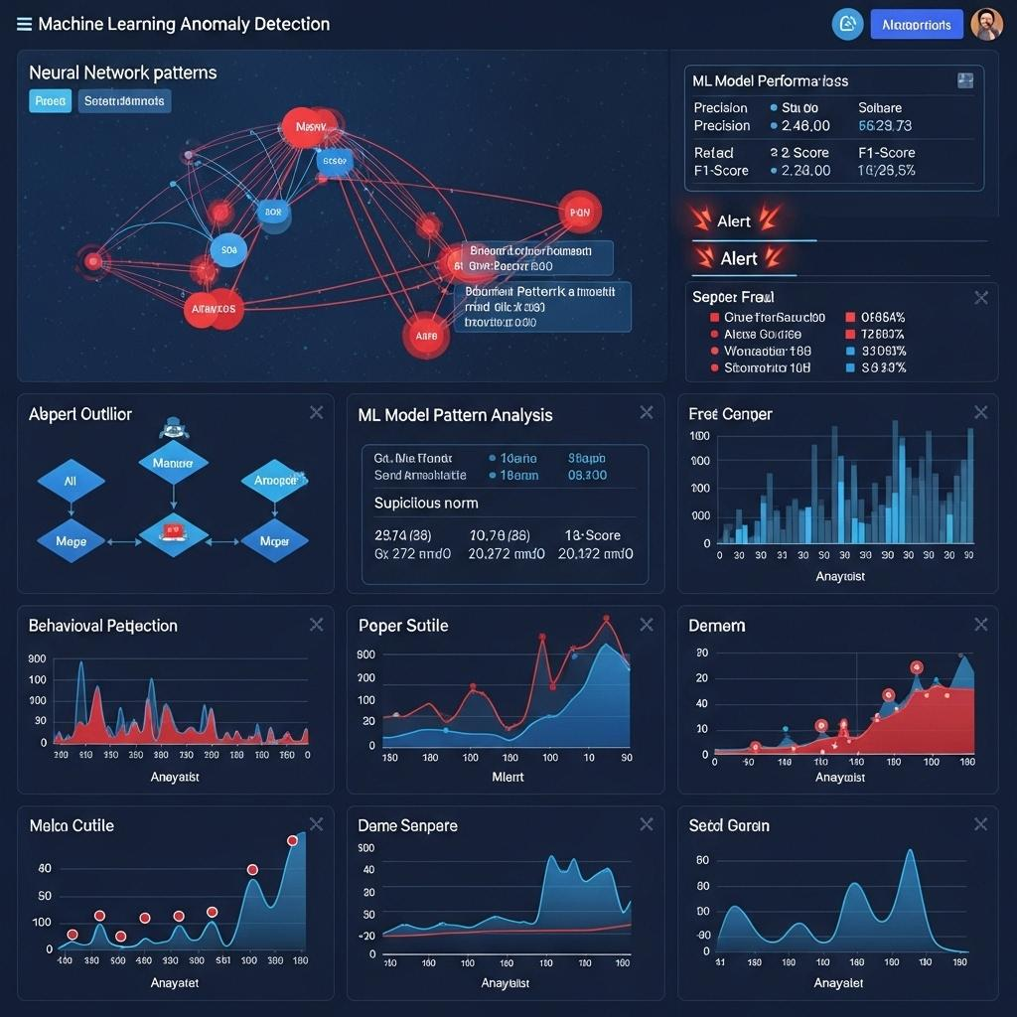
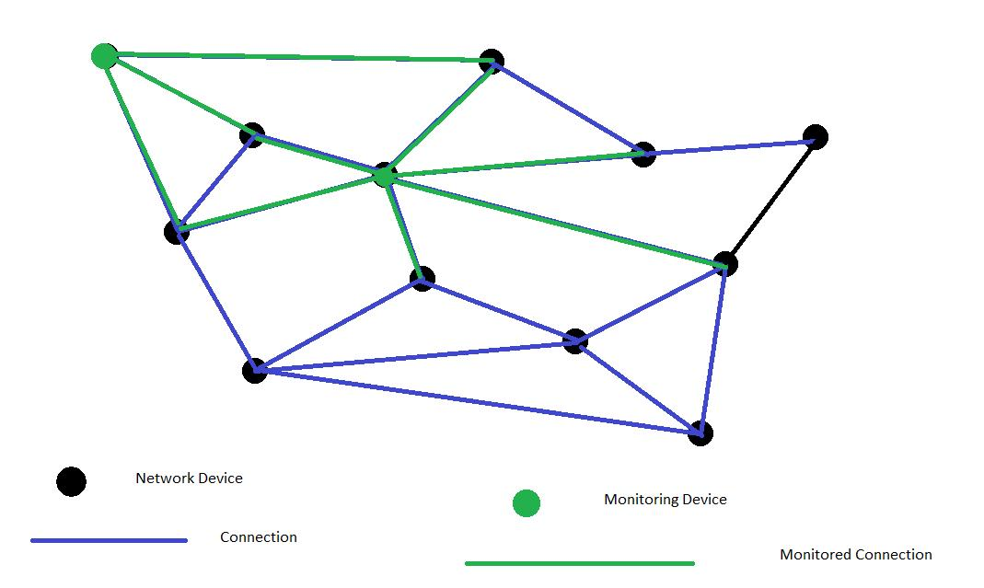
7

Real-Time Example – COVID-19 Analysis
During the COVID-19 pandemic:
Advanced detective work was used to:
- Track infection spread
- Identify hotspots
- Analyze trends
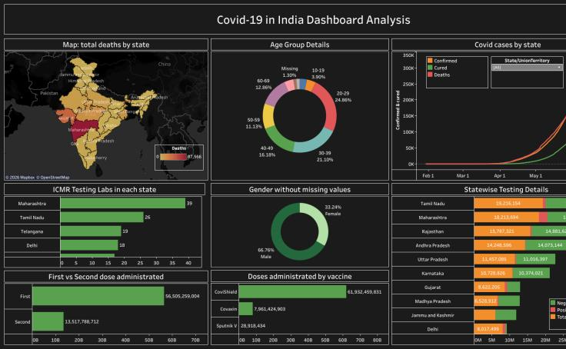
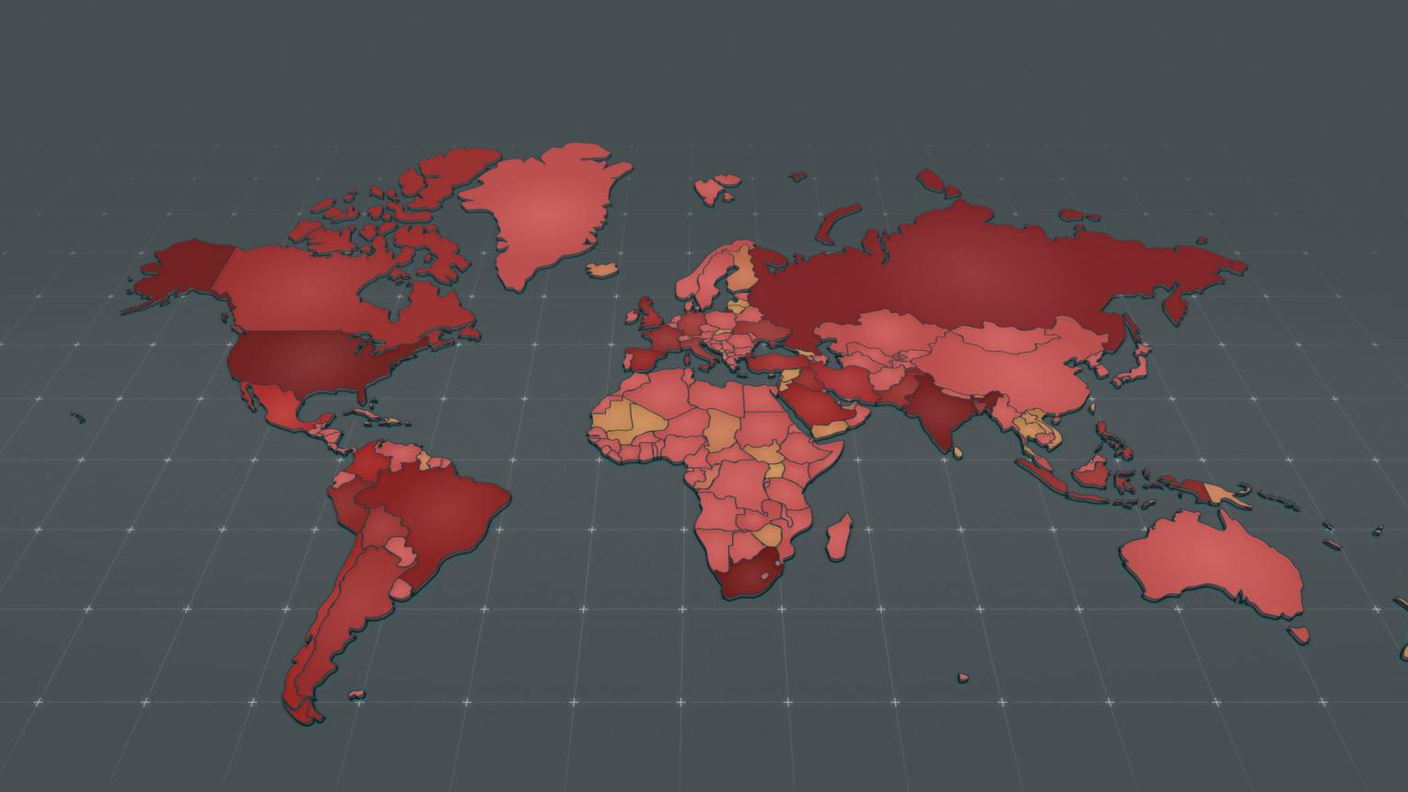
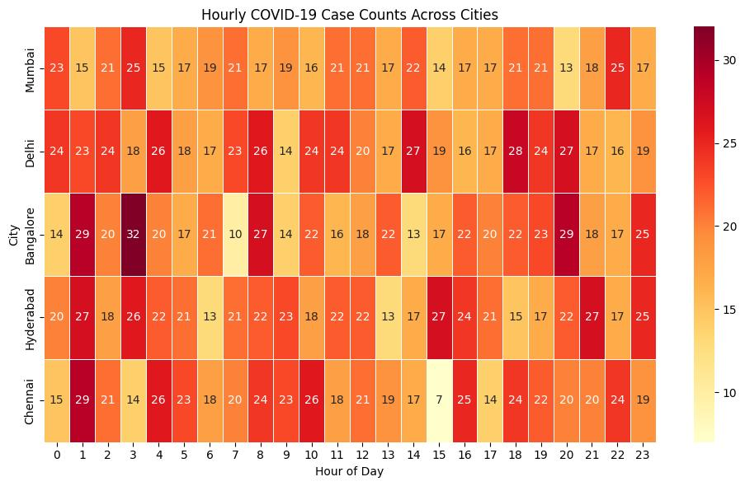
8

Advantages
- Finds hidden patterns
- Improves security systems
- Works with large datasets
- Supports real-time analysis
- Helps in decision-making

Disadvantages
- Requires advanced tools
- Complex algorithms
- High computation cost
- Privacy concerns

Conclusion
Advanced detective work in data visualization helps analyze complex data by finding hidden patterns, detecting anomalies, and extracting meaningful insights. It is widely used in banking, healthcare, cybersecurity, and real-world data systems for intelligent decision-making.

Tools for Gathering Clues

Tools for Gathering Clues (in Data Visualization & Advanced Detective Work)
Introduction
In data visualization and advanced detective work, “gathering clues” means collecting useful data from different sources to analyze patterns, detect anomalies, and extract insights. These clues are collected using various digital tools and techniques.
These tools help convert raw data into meaningful information for investigation and visualization.

Definition
Tools for gathering clues are software, techniques, and systems used to collect, extract, and prepare data from different sources for analysis and visualization.

Purpose of These Tools
- Collect raw data from multiple sources
- Extract useful patterns and information
- Support investigation and decision-making
- Prepare data for visualization
- Detect hidden relationships and anomalies

Types of Tools for Gathering Clues
1. Web Scraping Tools
Used to collect data from websites.
Examples:
- BeautifulSoup
- Scrapy
- Selenium
Use:
- Collect news data
- Extract product information
- Gather social media data

2. Database Query Tools
Used to retrieve structured data.
Example:
- SQL (Structured Query Language)
Use:
- Banking records
- Hospital data
- Business reports

3. Log Analysis Tools
Used to analyze system logs.
Examples:
- Splunk
- ELK Stack (Elasticsearch, Logstash, Kibana)
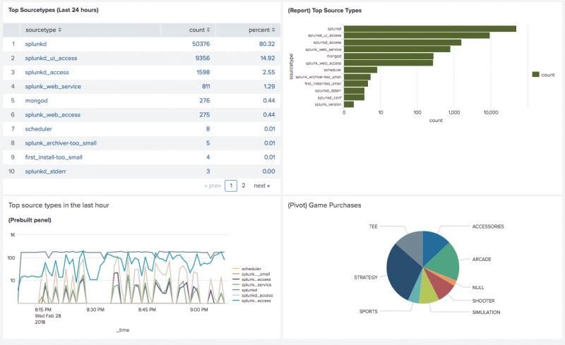
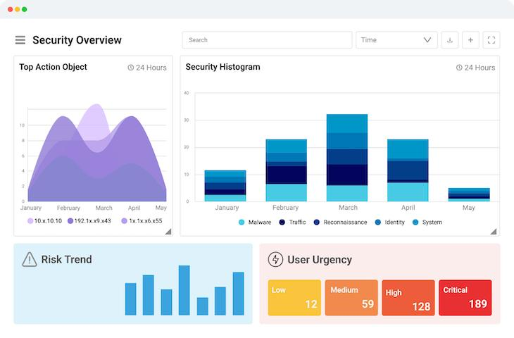
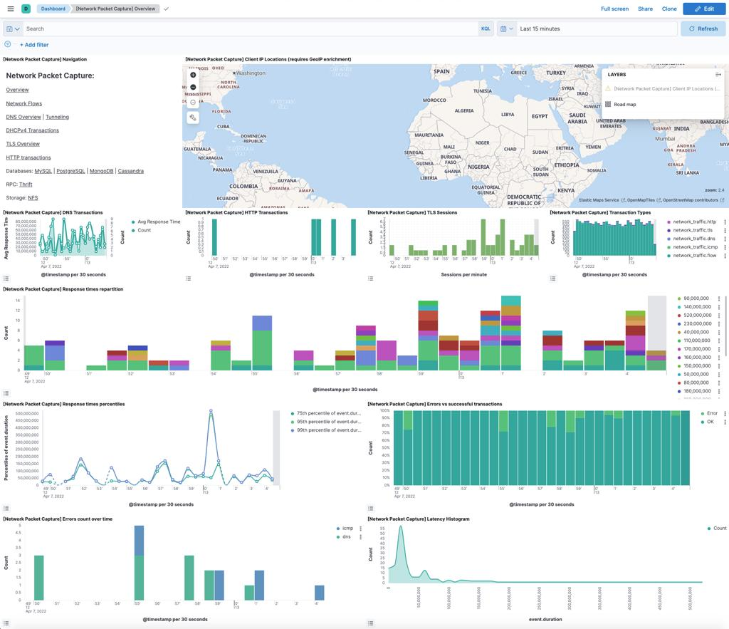
6

4. Data Mining Tools
Used to find hidden patterns in large datasets.
Examples:
- RapidMiner
- Weka
- Python (Pandas, NumPy)

5. Network Analysis Tools
Used to study relationships between entities.
Examples:
- Gephi
- Neo4j
- Cytoscape

6. API Data Collection Tools
Used to collect real-time data from applications.
Examples:
- REST APIs
- Postman

Working of Clue Gathering Tools
Step 1: Identify Data Source
- Websites
- Databases
- Sensors
- APIs

Step 2: Data Extraction
Tools collect raw data.

Step 3: Data Cleaning
Remove:
- Errors
- Duplicates
- Noise

Step 4: Data Structuring
Convert into usable format:
- Tables
- JSON
- XML

Step 5: Analysis & Visualization
Data is used in:
- Charts
- Graphs
- Dashboards

Real-Time Example – Cybersecurity Investigation
In cybersecurity systems:
- Log analysis tools detect suspicious login attempts
- Network tools track unusual connections
- Data mining finds attack patterns

Example Scenario
- Multiple failed login attempts from different locations
→ System flags it as a potential attack
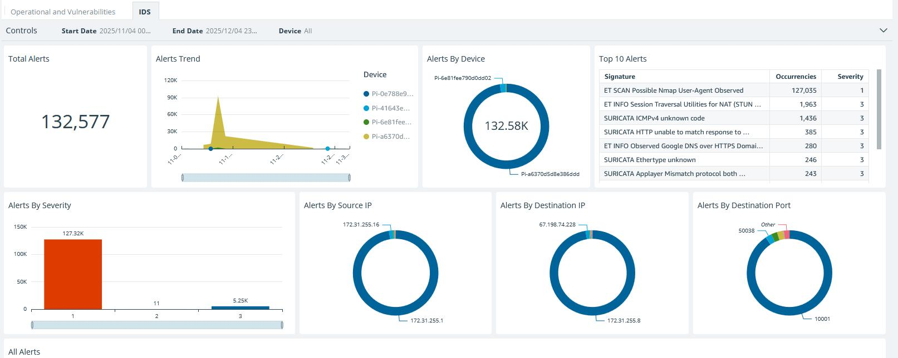
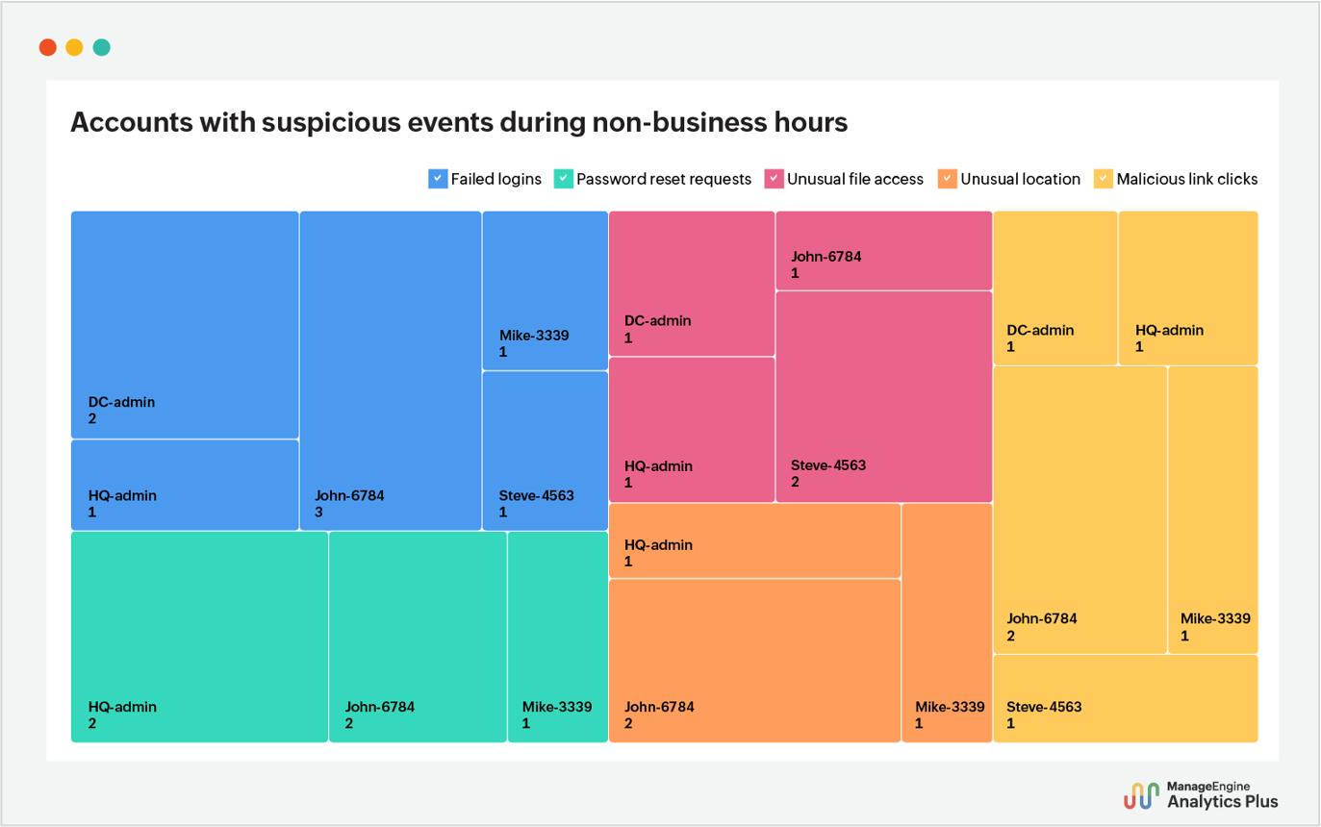
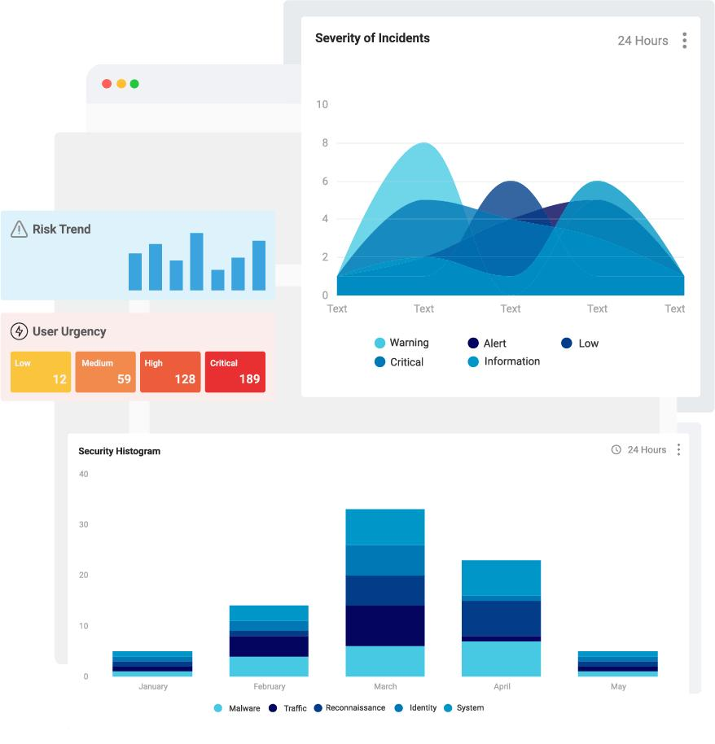
6

Real-Time Example – COVID-19 Data Collection
During the COVID-19 pandemic:
Tools were used to:
- Collect patient data
- Track infection cases
- Analyze spread patterns

Advantages
- Collects large amounts of data quickly
- Supports real-time analysis
- Helps in accurate decision-making
- Detects hidden patterns
- Improves visualization quality

Disadvantages
- Requires technical knowledge
- Some tools are expensive
- Privacy concerns
- Large data may be difficult to manage

Conclusion
Tools for gathering clues are essential in data visualization and advanced detective work. They help collect, clean, and prepare data from multiple sources so that meaningful insights can be discovered through visualization and analysis.

, Regular Expressions, Grammars and BNF Notation,

Regular Expressions, Grammars and BNF Notation (Data Visualization Context)

PAGE 1: INTRODUCTION
Introduction
In data visualization and text processing systems, we often need to understand, structure, and analyze data. For this purpose, three important concepts are used:
- Regular Expressions (Regex) → for pattern matching in text
- Grammars → for defining rules of a language
- BNF Notation → for formally describing grammar
These tools help in:
- Extracting useful data
- Validating input formats
- Parsing structured documents
- Preparing data for visualization

Importance
- Helps clean raw data before visualization
- Ensures correct data structure
- Used in compilers, browsers, and data systems
- Supports advanced data analysis

PAGE 2: REGULAR EXPRESSIONS (REGEX)
Definition
A Regular Expression is a pattern used to search, match, extract, or replace text in a dataset.

Features
- Pattern-based search
- Fast processing
- Works on large text data
- Used for validation and filtering

Basic Symbols
Symbol | Meaning
. | Any character
* | Zero or more
+ | One or more
? | Optional
^ | Start of string
$ | End of string
\d | Digit

Example
Age: 25, Marks: 90
Regex:
\d+
Output:
- 25
- 90

Working of Regex
- Input text
- Define pattern
- Match data
- Extract or replace

Real-Time Use
- Email validation
- Log file analysis
- Data cleaning for visualization

PAGE 3: GRAMMARS
Definition
A Grammar is a set of rules that defines how valid strings or expressions are formed in a language.

Components
1. Terminals
Actual symbols
Example: a, b, +, id

2. Non-Terminals
Variables representing structure
Example: <expr>

3. Production Rules
Rules for replacement
Example:
E → E + T

4. Start Symbol
Starting point of grammar
Example: E

Example Grammar
E → E + T | T
T → T * F | F
F → (E) | id

Working of Grammar
- Start from initial symbol
- Apply rules
- Generate valid expression
- Build structure

Example
Expression:
3 + 5 * 2
Grammar ensures correct structure and operator precedence.

PAGE 4: BNF NOTATION
Definition
BNF (Backus–Naur Form) is a formal notation used to describe grammar rules clearly and precisely.

Syntax
<symbol> ::= expression
- ::= means “is defined as”
- < > represents non-terminals

Example BNF (Arithmetic Expression)
<expr> ::= <expr> + <term> | <term>
<term> ::= <term> * <factor> | <factor>
<factor> ::= ( <expr> ) | number

Working of BNF
- Define grammar rules
- Parse input data
- Check validity
- Generate parse tree

Parse Tree Example
Expression:
3 + 5 * 2
Structure:
+
/ \
3 *
/ \
5 2

PAGE 5: RELATIONSHIP AND APPLICATIONS
Relationship
Concept | Purpose
Regex | Pattern matching in text
Grammar | Rules of structure
BNF | Formal representation of grammar

Applications
1. Data Visualization
- Clean and structure data before charts
2. Compilers
- Grammar defines language rules
- BNF defines syntax structure
3. Web Systems
- HTML/XML parsing
- Data validation
4. Text Processing
- Search and filter data
- Extract useful information

Real-Time Example – COVID-19 Data Processing
During the COVID-19 pandemic:
- Regex used to extract case numbers
- Grammar used to structure reports
- BNF used to define data formats (JSON/XML rules)

Example JSON Structure
<report> ::= { <cases>, <deaths>, <recovered> }
<cases> ::= number

PAGE 6: ADVANTAGES, DISADVANTAGES & CONCLUSION
Advantages
Regular Expressions
- Fast text search
- Easy data filtering
Grammar
- Defines structure clearly
- Helps parsing systems
BNF
- Formal and precise
- Used in compilers

Disadvantages
- Regex is complex for beginners
- Grammar rules can be difficult to design
- BNF is strict and less flexible

Comparison Table
Concept | Use
Regex | Text pattern matching
Grammar | Language structure rules
BNF | Formal syntax definition

Conclusion
Regular Expressions, Grammars, and BNF Notation are essential tools in data visualization and computing systems. They help in cleaning, structuring, validating, and analyzing data, making them crucial for compilers, web systems, and visualization pipelines.

If you want, I can also combine all your Unit-III topics into a single exam PDF / revision guide / handwritten notes format.

explain in data visualization

Regular Expressions, Grammars and BNF Notation (in Data Visualization)

PAGE 1: INTRODUCTION
Introduction
In data visualization, raw data is often messy, unstructured, and inconsistent. Before converting it into graphs, charts, or dashboards, we must clean, structure, and validate the data.
For this, three important tools are used:
- Regular Expressions (Regex) → extract and clean data
- Grammars → define structure of data
- BNF Notation → formally describe data format rules
These are part of the data preprocessing stage in visualization pipelines.

Why it is important in Visualization
- Removes unwanted text/noise
- Extracts useful values for charts
- Ensures correct data format
- Helps convert raw data → structured data

PAGE 2: REGULAR EXPRESSIONS IN DATA VISUALIZATION
Meaning
Regular Expressions are used to extract specific patterns from raw data before visualization.

Role in Visualization Pipeline
Raw Data → Regex Cleaning → Structured Data → Charts/Graphs

Uses
1. Data Cleaning
Removes unwanted characters.
Example:
Price: $500, $600, $700
Regex extracts only numbers:
500, 600, 700

2. Feature Extraction
Extract useful values from text logs.
Example:
- Extracting dates, time, or IDs from logs

3. Validation
Ensures correct format before visualization.
Example:
- Email, phone number validation

Real Visualization Use
Before creating a graph:
- Regex extracts numeric values
- Removes symbols like $, %, text

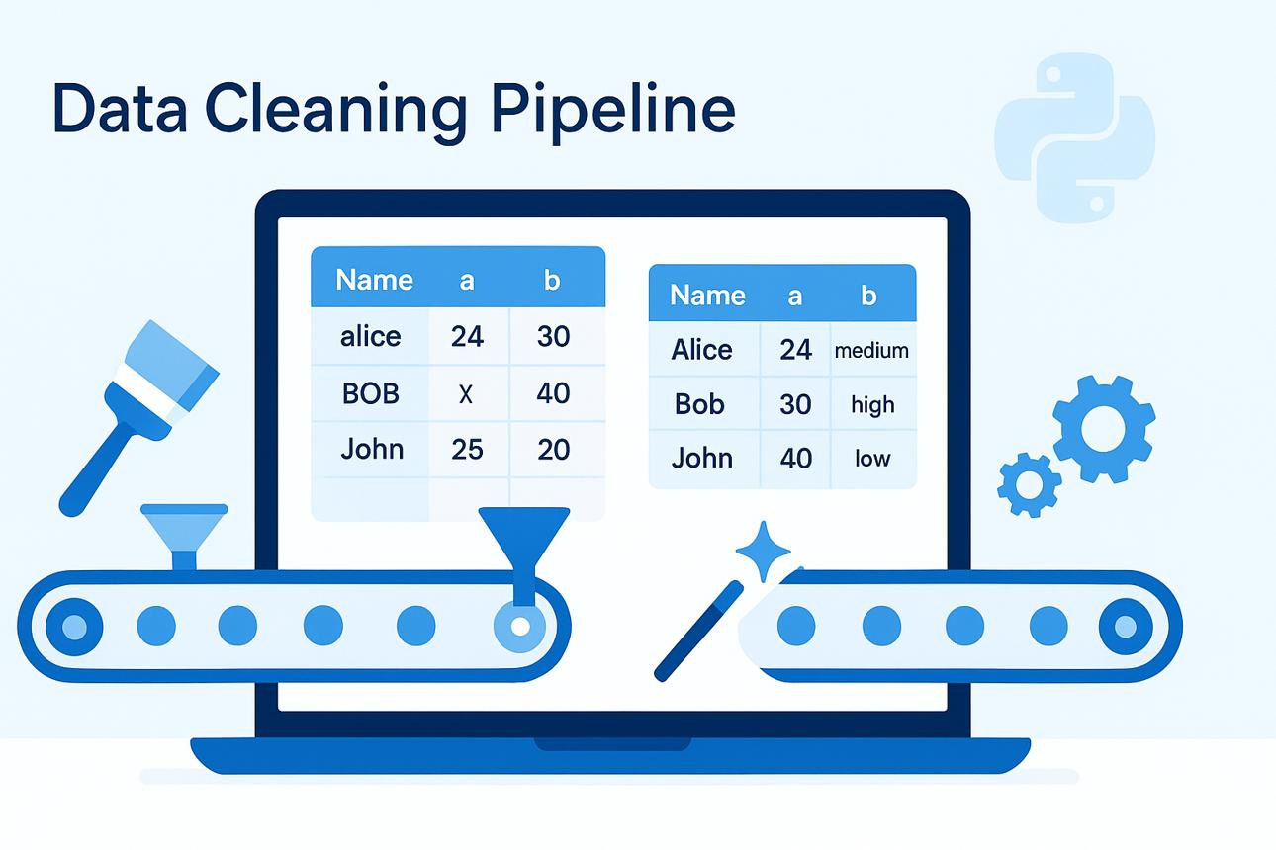
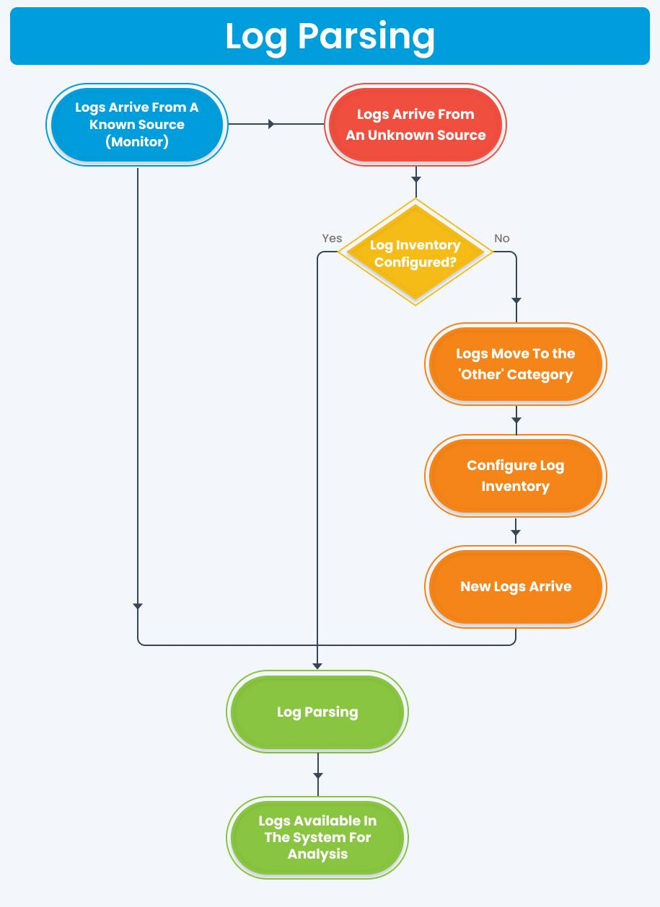

7

PAGE 3: GRAMMARS IN DATA VISUALIZATION
Meaning
Grammar defines the structure of data so visualization tools can understand relationships.

Role in Visualization
Grammar ensures data is:
- Properly structured
- Consistent
- Machine-readable

Example in Visualization Context
Raw Data:
Name: John, Marks: 80
Grammar rule:
Student → Name Marks
Marks → Number
Now system knows:
- Name field
- Marks field

Use in Visualization Systems
1. Structured Data Formatting
Ensures data fits into:
- Tables
- Charts
- Graphs

2. Data Parsing
Used in converting raw data into structured form.

3. JSON/XML Visualization
Grammars define structure of APIs used in dashboards.

Real Visualization Example
- Student performance dashboards
- Business reports

PAGE 4: BNF NOTATION IN DATA VISUALIZATION
Meaning
BNF is a formal way to define grammar rules for structured data used in visualization systems.

Role in Visualization
BNF helps in:
- Defining data structure clearly
- Validating datasets
- Ensuring correct parsing before visualization

Example (Data Format for Dashboard)
<report> ::= <title> <data>
<data> ::= <value> | <data> , <value>
This ensures:
- Data is in correct format
- Visualization tool can safely process it

Use Cases
1. API Data Structure
Defines format of JSON/XML used in dashboards
2. Data Validation
Ensures correct input before plotting graphs

Parse Structure in Visualization
Data → BNF Rules → Structured Data → Graphs

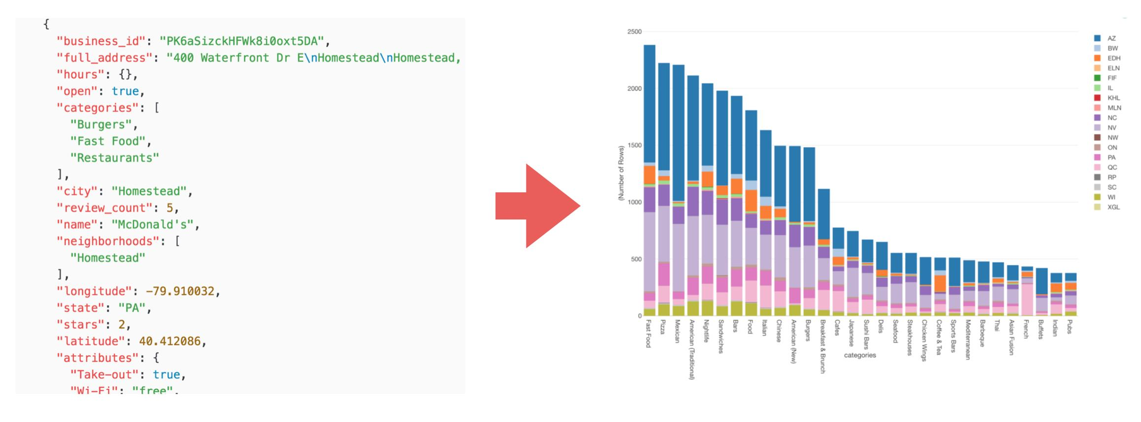
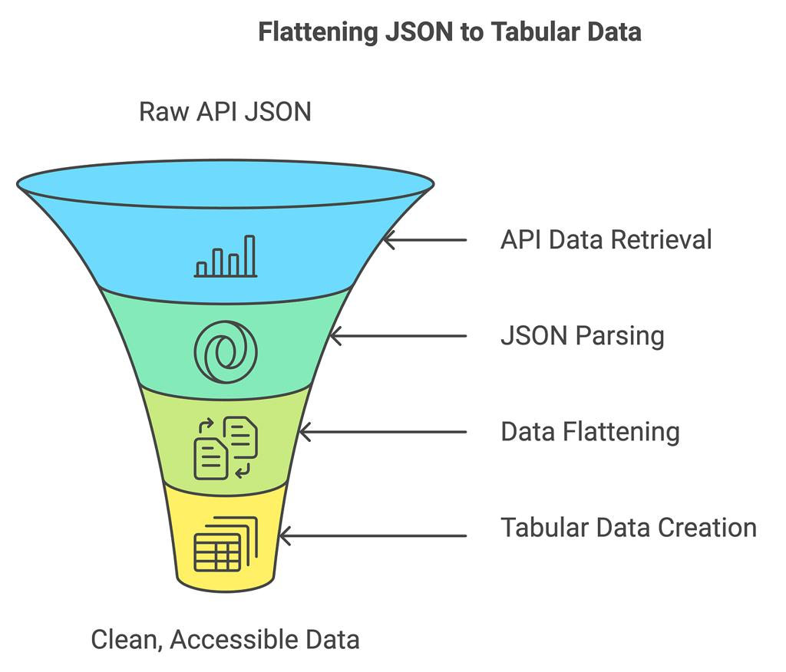
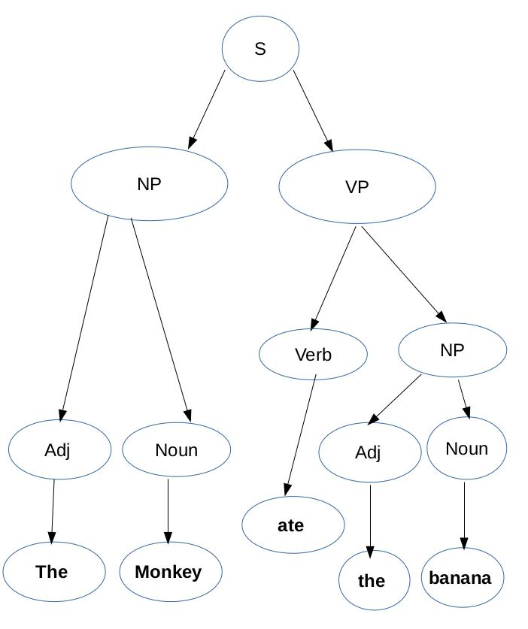
7

PAGE 5: COMBINED WORKING IN DATA VISUALIZATION
Full Workflow
Step 1: Raw Data Collection
- Logs
- Text files
- APIs

Step 2: Regex Processing
- Extract numbers
- Remove symbols
- Clean text

Step 3: Grammar Structuring
- Organize fields
- Define relationships

Step 4: BNF Validation
- Ensure format correctness
- Validate structure

Step 5: Visualization
- Charts
- Graphs
- Dashboards

Example (Sales Data Visualization)
Raw Data:
Product: A, Price: $100
Product: B, Price: $200
Regex Output:
100, 200
Grammar Structure:
Product → Name Price
Visualization:
- Bar chart of sales

PAGE 6: REAL-TIME EXAMPLE + CONCLUSION
Real-Time Example – COVID-19 Dashboard
During the COVID-19 pandemic:
Step 1: Data Collection
- Hospital reports
- Government APIs
Step 2: Regex Use
- Extract case numbers from text reports
Step 3: Grammar Use
- Structure data into fields:
  - cases
  - deaths
  - recovered
Step 4: BNF Use
- Define format of JSON/XML data
Step 5: Visualization
- Heatmaps
- Line graphs
- Dashboards

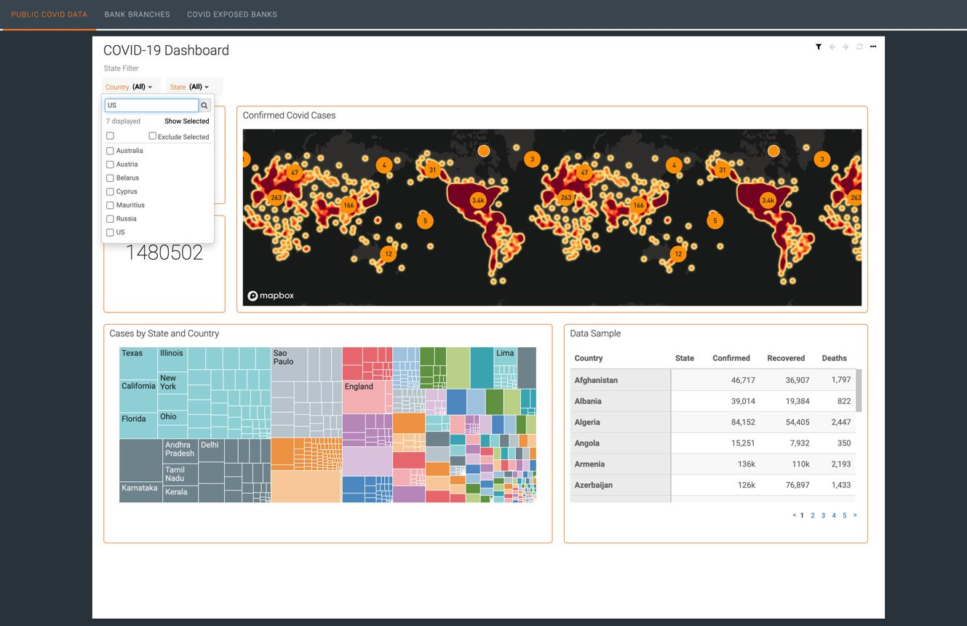
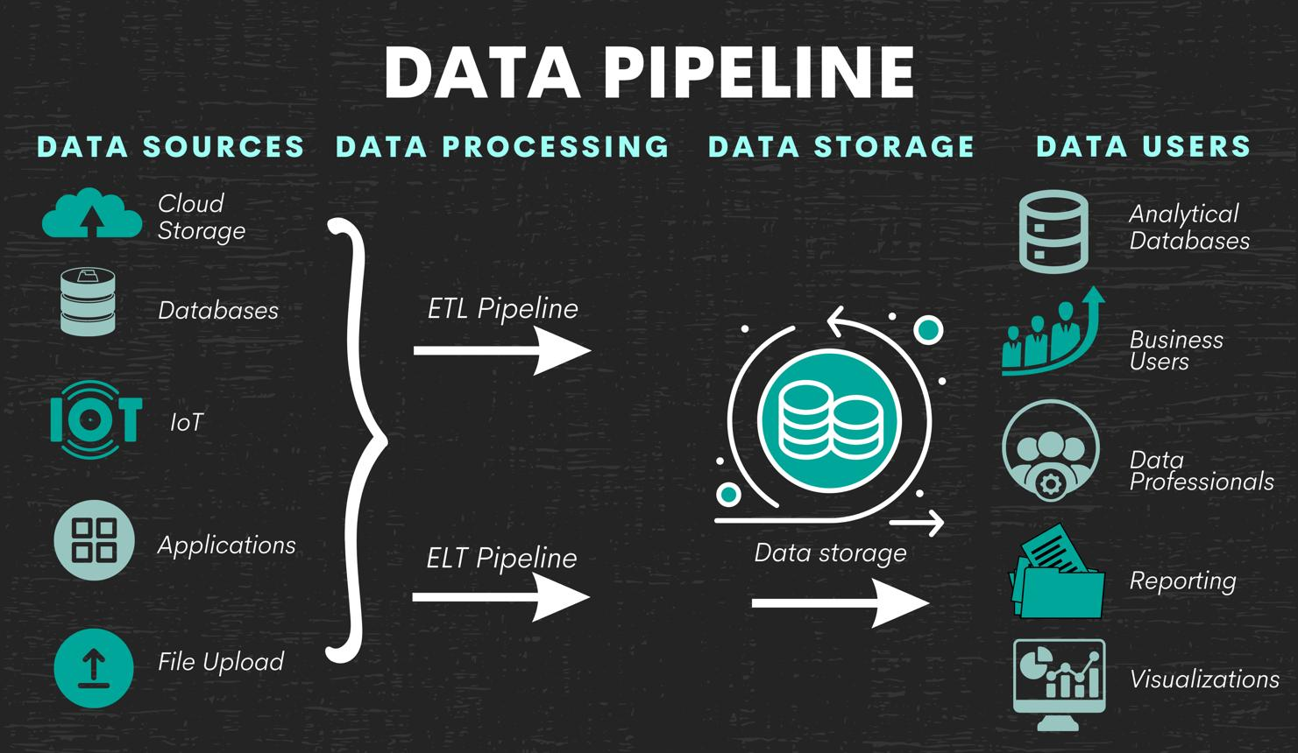
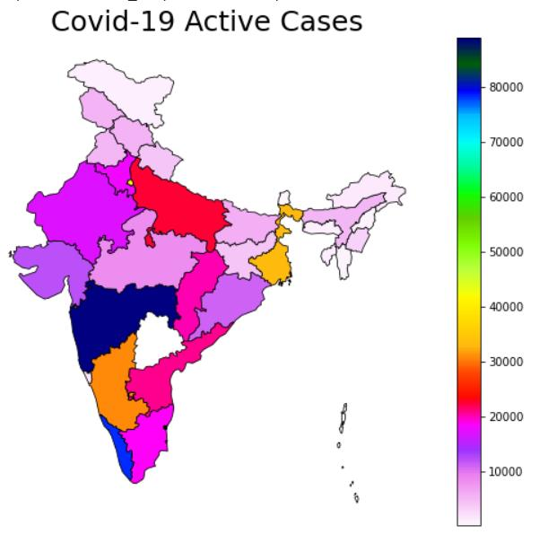
6

Advantages
- Improves data accuracy
- Removes noise before visualization
- Ensures structured datasets
- Supports real-time analytics

Disadvantages
- Regex is complex for beginners
- Grammar design is difficult
- BNF is rigid and strict

Conclusion
In data visualization, Regular Expressions, Grammars, and BNF Notation play a crucial role in transforming raw data into structured, meaningful, and visual information. They are essential in preprocessing, validation, and organizing data before it is displayed in charts, graphs, and dashboards.

If you want, I can combine all Unit-III answers into one complete revision PDF or 50-page exam notes file.

Tools for Gathering Clues (in Data Visualization & Advanced Detective Work)
Introduction
In data visualization and advanced detective work, “gathering clues” means collecting useful data from different sources to analyze patterns, detect anomalies, and extract insights. These clues are collected using various digital tools and techniques.
These tools help convert raw data into meaningful information for investigation and visualization.

Definition
Tools for gathering clues are software, techniques, and systems used to collect, extract, and prepare data from different sources for analysis and visualization.

Purpose of These Tools
- Collect raw data from multiple sources
- Extract useful patterns and information
- Support investigation and decision-making
- Prepare data for visualization
- Detect hidden relationships and anomalies

Types of Tools for Gathering Clues
1. Web Scraping Tools
Used to collect data from websites.
Examples:
- BeautifulSoup
- Scrapy
- Selenium
Use:
- Collect news data
- Extract product information
- Gather social media data

2. Database Query Tools
Used to retrieve structured data.
Example:
- SQL (Structured Query Language)
Use:
- Banking records
- Hospital data
- Business reports

3. Log Analysis Tools
Used to analyze system logs.
Examples:
- Splunk
- ELK Stack (Elasticsearch, Logstash, Kibana)



6

4. Data Mining Tools
Used to find hidden patterns in large datasets.
Examples:
- RapidMiner
- Weka
- Python (Pandas, NumPy)

5. Network Analysis Tools
Used to study relationships between entities.
Examples:
- Gephi
- Neo4j
- Cytoscape

6. API Data Collection Tools
Used to collect real-time data from applications.
Examples:
- REST APIs
- Postman

Working of Clue Gathering Tools
Step 1: Identify Data Source
- Websites
- Databases
- Sensors
- APIs

Step 2: Data Extraction
Tools collect raw data.

Step 3: Data Cleaning
Remove:
- Errors
- Duplicates
- Noise

Step 4: Data Structuring
Convert into usable format:
- Tables
- JSON
- XML

Step 5: Analysis & Visualization
Data is used in:
- Charts
- Graphs
- Dashboards

Real-Time Example – Cybersecurity Investigation
In cybersecurity systems:
- Log analysis tools detect suspicious login attempts
- Network tools track unusual connections
- Data mining finds attack patterns

Example Scenario
- Multiple failed login attempts from different locations
→ System flags it as a potential attack



6

Real-Time Example – COVID-19 Data Collection
During the COVID-19 pandemic:
Tools were used to:
- Collect patient data
- Track infection cases
- Analyze spread patterns

Advantages
- Collects large amounts of data quickly
- Supports real-time analysis
- Helps in accurate decision-making
- Detects hidden patterns
- Improves visualization quality

Disadvantages
- Requires technical knowledge
- Some tools are expensive
- Privacy concerns
- Large data may be difficult to manage

Conclusion
Tools for gathering clues are essential in data visualization and advanced detective work. They help collect, clean, and prepare data from multiple sources so that meaningful insights can be discovered through visualization and analysis.
, Regular Expressions, Grammars and BNF Notation,
Regular Expressions, Grammars and BNF Notation (Data Visualization Context)

PAGE 1: INTRODUCTION
Introduction
In data visualization and text processing systems, we often need to understand, structure, and analyze data. For this purpose, three important concepts are used:
- Regular Expressions (Regex) → for pattern matching in text
- Grammars → for defining rules of a language
- BNF Notation → for formally describing grammar
These tools help in:
- Extracting useful data
- Validating input formats
- Parsing structured documents
- Preparing data for visualization

Importance
- Helps clean raw data before visualization
- Ensures correct data structure
- Used in compilers, browsers, and data systems
- Supports advanced data analysis

PAGE 2: REGULAR EXPRESSIONS (REGEX)
Definition
A Regular Expression is a pattern used to search, match, extract, or replace text in a dataset.

Features
- Pattern-based search
- Fast processing
- Works on large text data
- Used for validation and filtering

Basic Symbols
Symbol | Meaning
. | Any character
* | Zero or more
+ | One or more
? | Optional
^ | Start of string
$ | End of string
\d | Digit

Example
Age: 25, Marks: 90
Regex:
\d+
Output:
- 25
- 90

Working of Regex
- Input text
- Define pattern
- Match data
- Extract or replace

Real-Time Use
- Email validation
- Log file analysis
- Data cleaning for visualization

PAGE 3: GRAMMARS
Definition
A Grammar is a set of rules that defines how valid strings or expressions are formed in a language.

Components
1. Terminals
Actual symbols
Example: a, b, +, id

2. Non-Terminals
Variables representing structure
Example: <expr>

3. Production Rules
Rules for replacement
Example:
E → E + T

4. Start Symbol
Starting point of grammar
Example: E

Example Grammar
E → E + T | T
T → T * F | F
F → (E) | id

Working of Grammar
- Start from initial symbol
- Apply rules
- Generate valid expression
- Build structure

Example
Expression:
3 + 5 * 2
Grammar ensures correct structure and operator precedence.

PAGE 4: BNF NOTATION
Definition
BNF (Backus–Naur Form) is a formal notation used to describe grammar rules clearly and precisely.

Syntax
<symbol> ::= expression
- ::= means “is defined as”
- < > represents non-terminals

Example BNF (Arithmetic Expression)
<expr> ::= <expr> + <term> | <term>
<term> ::= <term> * <factor> | <factor>
<factor> ::= ( <expr> ) | number

Working of BNF
- Define grammar rules
- Parse input data
- Check validity
- Generate parse tree

Parse Tree Example
Expression:
3 + 5 * 2
Structure:
+
/ \
3 *
/ \
5 2

PAGE 5: RELATIONSHIP AND APPLICATIONS
Relationship
Concept | Purpose
Regex | Pattern matching in text
Grammar | Rules of structure
BNF | Formal representation of grammar

Applications
1. Data Visualization
- Clean and structure data before charts
2. Compilers
- Grammar defines language rules
- BNF defines syntax structure
3. Web Systems
- HTML/XML parsing
- Data validation
4. Text Processing
- Search and filter data
- Extract useful information

Real-Time Example – COVID-19 Data Processing
During the COVID-19 pandemic:
- Regex used to extract case numbers
- Grammar used to structure reports
- BNF used to define data formats (JSON/XML rules)

Example JSON Structure
<report> ::= { <cases>, <deaths>, <recovered> }
<cases> ::= number

PAGE 6: ADVANTAGES, DISADVANTAGES & CONCLUSION
Advantages
Regular Expressions
- Fast text search
- Easy data filtering
Grammar
- Defines structure clearly
- Helps parsing systems
BNF
- Formal and precise
- Used in compilers

Disadvantages
- Regex is complex for beginners
- Grammar rules can be difficult to design
- BNF is strict and less flexible

Comparison Table
Concept | Use
Regex | Text pattern matching
Grammar | Language structure rules
BNF | Formal syntax definition

Conclusion
Regular Expressions, Grammars, and BNF Notation are essential tools in data visualization and computing systems. They help in cleaning, structuring, validating, and analyzing data, making them crucial for compilers, web systems, and visualization pipelines.

If you want, I can also combine all your Unit-III topics into a single exam PDF / revision guide / handwritten notes format.
explain in data visualization
Regular Expressions, Grammars and BNF Notation (in Data Visualization)

PAGE 1: INTRODUCTION
Introduction
In data visualization, raw data is often messy, unstructured, and inconsistent. Before converting it into graphs, charts, or dashboards, we must clean, structure, and validate the data.
For this, three important tools are used:
- Regular Expressions (Regex) → extract and clean data
- Grammars → define structure of data
- BNF Notation → formally describe data format rules
These are part of the data preprocessing stage in visualization pipelines.

Why it is important in Visualization
- Removes unwanted text/noise
- Extracts useful values for charts
- Ensures correct data format
- Helps convert raw data → structured data

PAGE 2: REGULAR EXPRESSIONS IN DATA VISUALIZATION
Meaning
Regular Expressions are used to extract specific patterns from raw data before visualization.

Role in Visualization Pipeline
Raw Data → Regex Cleaning → Structured Data → Charts/Graphs

Uses
1. Data Cleaning
Removes unwanted characters.
Example:
Price: $500, $600, $700
Regex extracts only numbers:
500, 600, 700

2. Feature Extraction
Extract useful values from text logs.
Example:
- Extracting dates, time, or IDs from logs

3. Validation
Ensures correct format before visualization.
Example:
- Email, phone number validation

Real Visualization Use
Before creating a graph:
- Regex extracts numeric values
- Removes symbols like $, %, text





PAGE 3: GRAMMARS IN DATA VISUALIZATION
Meaning
Grammar defines the structure of data so visualization tools can understand relationships.

Role in Visualization
Grammar ensures data is:
- Properly structured
- Consistent
- Machine-readable

Example in Visualization Context
Raw Data:
Name: John, Marks: 80
Grammar rule:
Student → Name Marks
Marks → Number
Now system knows:
- Name field
- Marks field

Use in Visualization Systems
1. Structured Data Formatting
Ensures data fits into:
- Tables
- Charts
- Graphs

2. Data Parsing
Used in converting raw data into structured form.

3. JSON/XML Visualization
Grammars define structure of APIs used in dashboards.

Real Visualization Example
- Student performance dashboards
- Business reports

PAGE 4: BNF NOTATION IN DATA VISUALIZATION
Meaning
BNF is a formal way to define grammar rules for structured data used in visualization systems.

Role in Visualization
BNF helps in:
- Defining data structure clearly
- Validating datasets
- Ensuring correct parsing before visualization

Example (Data Format for Dashboard)
<report> ::= <title> <data>
<data> ::= <value> | <data> , <value>
This ensures:
- Data is in correct format
- Visualization tool can safely process it

Use Cases
1. API Data Structure
Defines format of JSON/XML used in dashboards
2. Data Validation
Ensures correct input before plotting graphs

Parse Structure in Visualization
Data → BNF Rules → Structured Data → Graphs




7

PAGE 5: COMBINED WORKING IN DATA VISUALIZATION
Full Workflow
Step 1: Raw Data Collection
- Logs
- Text files
- APIs

Step 2: Regex Processing
- Extract numbers
- Remove symbols
- Clean text

Step 3: Grammar Structuring
- Organize fields
- Define relationships

Step 4: BNF Validation
- Ensure format correctness
- Validate structure

Step 5: Visualization
- Charts
- Graphs
- Dashboards

Example (Sales Data Visualization)
Raw Data:
Product: A, Price: $100
Product: B, Price: $200
Regex Output:
100, 200
Grammar Structure:
Product → Name Price
Visualization:
- Bar chart of sales

PAGE 6: REAL-TIME EXAMPLE + CONCLUSION
Real-Time Example – COVID-19 Dashboard
During the COVID-19 pandemic:
Step 1: Data Collection
- Hospital reports
- Government APIs
Step 2: Regex Use
- Extract case numbers from text reports
Step 3: Grammar Use
- Structure data into fields:
  - cases
  - deaths
  - recovered
Step 4: BNF Use
- Define format of JSON/XML data
Step 5: Visualization
- Heatmaps
- Line graphs
- Dashboards




6

Advantages
- Improves data accuracy
- Removes noise before visualization
- Ensures structured datasets
- Supports real-time analytics

Disadvantages
- Regex is complex for beginners
- Grammar design is difficult
- BNF is rigid and strict

Conclusion
In data visualization, Regular Expressions, Grammars, and BNF Notation play a crucial role in transforming raw data into structured, meaningful, and visual information. They are essential in preprocessing, validation, and organizing data before it is displayed in charts, graphs, and dashboards.

